|  |  |  |
| --- | --- | --- |
| DOCENTE | SANDRA MENDOZA  smendoza@educacionbogota.edu.co | |
| ESTUDIANTE |  | |
| CURSO | 7º |  |

1. **Traducir el texto**

***My Wonderful Family***

*I live in a house near the mountains. I have two brothers and one sister, and I was born last. My father teaches mathematics, and my mother is a nurse at a big hospital. My brothers are very smart and work hard in school. My sister is a nervous girl, but she is very kind. My grandmother also lives with us. She came from Italy when I was two years old. She has grown old, but she is still very strong. She cooks the best food!*

*My family is very important to me. We do lots of things together. My brothers and I like to go on long walks in the mountains. My sister likes to cook with my grandmother. On the weekends we all play board games together. We laugh and always have a good time. I love my family very much.*

1. **Escoger la respuesta correcta**
2. My mother is a...

Doctor Writer

Waitress Nurse

1. My house is near the...

Italy City

Mountains Monastery

1. On the weekends, we...

Go to movie Play board games together

Clean the house Cook pasta

1. **Completar la conversación**

A: What is your name? _______________________

A: What is your last name? ____________________

A: Where are you from? _______________________

A: what is your nationality? _____________________

A: How old are you? __________________________

A: What grade are you in? ______________________

**Tomado de:** [**http://eduteka.icesi.edu.co/proyectos.php/1/20830**](http://eduteka.icesi.edu.co/proyectos.php/1/20830)

1. **Colocar la palabra correcta**

A. _______ name is Neil. I am a teacher.

B. That is your sister! What is ________ name?

C. ________ are Monica and Paula and our nationality is Italian.

D. What is ________ job? She is a teacher.

E. _______ am from England. Are you from England too?

F. What is Bill's job? _______ is a waiter.

G. We are from Rome. _______ house is very big.

H. "What is your name?" "______ name is Veronica."

I. I have a dog and ________ name is Toby.

J. My mother is 48 and ________ is a nurse.

Tomado de:<https://www.esl-lounge.com/student/grammar/1g6-pronoun-or-adjective.php>

1. **Enumerar las figuras con el verbo correcto**

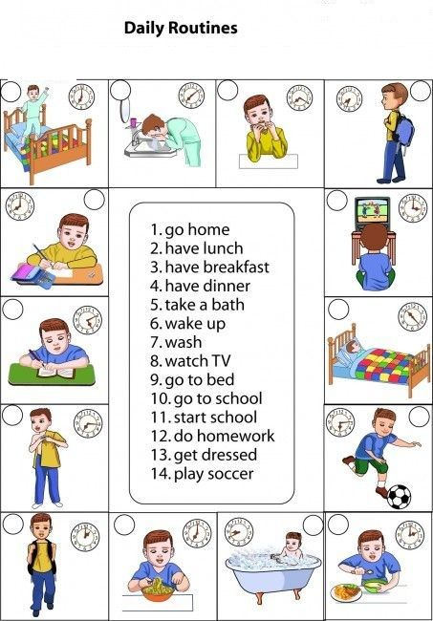

1. **Realizar un texto que describa la mayoría de las actividades que hace Billy en el día**

Billy is an active boy. He goes home in the afternoon.

Billy has breakfast and lunch in his house, He.............

1. **Siguiendo el link, desarrollar las páginas 11 y 12 completas. En la página 15 desarrollar el ejercicio 5:**

<http://aprende.colombiaaprende.edu.co/sites/default/files/naspublic/bilinguismo/WAY_TO_GO_6_7_8/WAY_TO_GO_7_LIBRO_ESTUDIANTE.pdf>

1. **Siguiendo el link, desarrollar la página 3 completa. El punto 1 de la página 4 y los seis primeros puntos de la página 6:**

<http://aprende.colombiaaprende.edu.co/sites/default/files/naspublic/bilinguismo/WAY_TO_GO_6_7_8/WAY_TO_GO_7_LIBRO_DE_TRABAJO.pdf>