|  |  |  |  |
| --- | --- | --- | --- |
| DOCENTE | LILIANA ARTEAGA | | |
| ESTUDIANTE |  | | |
| CURSO | 804 | FECHA ENTREGA |  |
| E-MAIL | ilarteaga@educacionbogota.edu.co | | |

1. 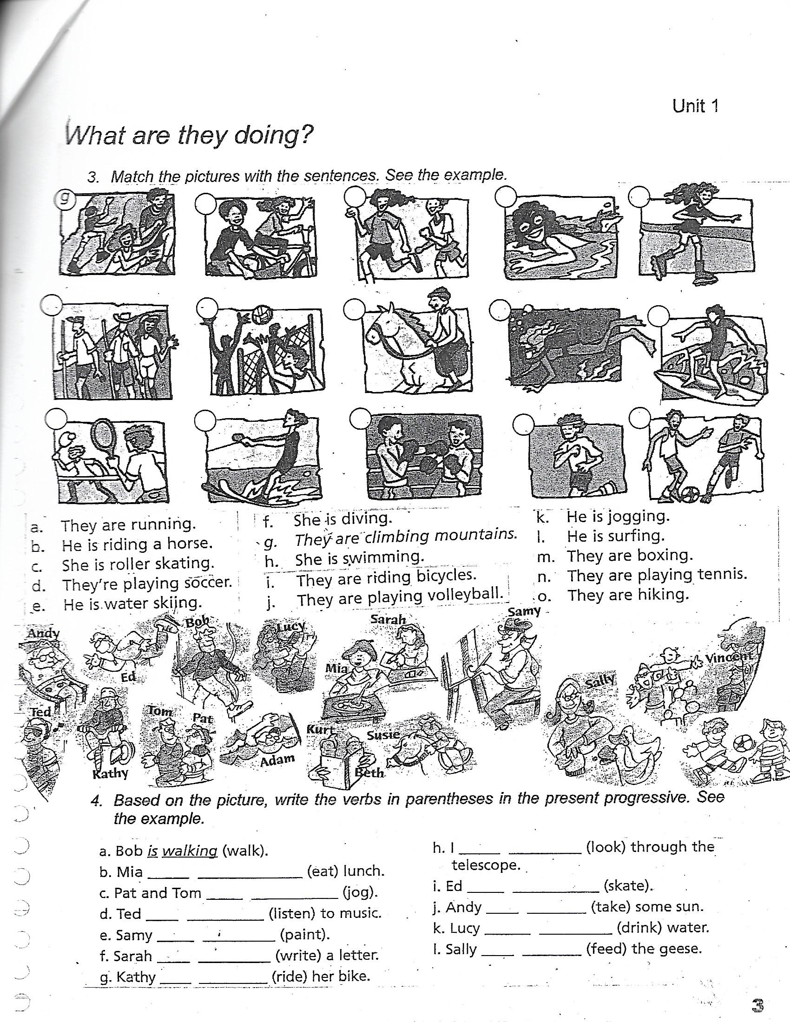**Match the pictures with the sentences. See the example. Then, write the sentences in a negative and interrogative form.**





1. They are running.
2. He is riding a horse.
3. She is roller skating.
4. They are playing soccer.
5. He is water skiing.
6. She is diving.
7. They are climbing mountains.
8. She is swimming.
9. They are riding bicycles.
10. They are playing Volleyball.
11. He is jogging.
12. He is surfing.
13. They are boxing.
14. They are playing tennis.

II.

1. **Fill in the blanks with “am” “is” or “are”.**
2. I_______ cooking a turkey for dinner.
3. Mom ______ setting the table.
4. Jhon ______ making cofee.
5. The boys ______ watching TV.
6. It ______ snowing today.
7. We ______ painting Easter eggs.
8. The dog ______ barking.
9. You ______ wearing a red jacket.
10. **Write the correct “ing” verb in the blank.**
11. We is __________ dinner (prepare).
12. They are _________ money (save).
13. You are __________ a nice song. (sing)
14. The children are _________ fruits. (eat)
15. Sam is _________ lunch. (have).
16. I am __________ coffee. (drink).
17. They are _________ English. (speak).
18. He is __________ in the park. (jog)
19. **Negative form. Fill in blanks with am /is/are +not.**
20. I ___________ cooking.
21. It ___________ raining
22. Mary __________ sleeping.
23. Kate and Jhon _________ watching movies.
24. She __________ listening to music.
25. We ____________ riding a horse.
26. I _____________ skating.
27. You ____________ watering the flowers.
28. **Make a question. Fill in the blank with am/is/are and “ing” verb.**
29. ________ I ____________ dinner? (cook)
30. ________ Jack __________ pie? (bake)
31. ________ the girls __________? (eat)
32. ________ it ____________? (snowimg)
33. ________ the cat ___________? (play)
34. ________ you ____________ in London? (work)
35. ________ the babies ___________? (cry)
36. ________ Katie ___________ a letter? (write)