**GUÍA No. 4 – INTERDISCIPLINAR (BACHILLERATO)**

**GRADO:** __Decimo__

|  |  |  |  |
| --- | --- | --- | --- |
| **DOCENTE** | **GRUPO** | **E-MAIL** | |
| NICOLAS MANRIQUE | DECIMO | [mestefannic@educacionbogota.edu.co](mailto:mestefannic@educacionbogota.edu.co) | |
| **TEMA** | Passive Voice // Verbs in past participle | | |
| **OBJETIVOS** | | | **INDICADOR (ES) DE DESEMPEÑO:** |
| * Identificar el pasado participio de algunos verbos en ingles * Conocer la estructura gramatical del passive voice y como se utiliza en presente y pasado simple | | | * Realiza oraciones haciendo uso de la nueva estructura gramatical aprendida. |
| **AREAS - ASIGNATURAS INVOLUCRADAS:**  **INGLÉS** | | | **PRODUCTO A ENTREGAR: GUÍA 4** |

***Busca los siguientes verbos en pasado participio.***

EATEN COME GONE UNDERSTOOD DRIVEN DRUNK FLOWN KNOWN SEEN FOUND

WRITTEN READ SLEPT BEEN DONE MADE GOTTEN HAD BOUGHT GIVEN MET

SENT WON DRAWN CHOSEN BROKEN LEARNT LEFT FOUGHT PAID

|  |  |  |  |  |  |  |  |  |  |  |  |  |  |  |  |  |  |  |  |
| --- | --- | --- | --- | --- | --- | --- | --- | --- | --- | --- | --- | --- | --- | --- | --- | --- | --- | --- | --- |
| E | A | T | E | N | R | K | S | C | N | E | K | O | P | S | J | M | B | N | E |
| T | C | B | N | M | J | S | E | A | Q | F | T | P | E | L | S | W | E | F | W |
| N | B | C | E | X | Z | A | N | Q | E | T | Y | U | I | O | O | P | N | K | R |
| B | N | M | T | E | U | I | T | O | E | D | A | M | O | O | E | E | O | I | I |
| Q | D | D | E | D | N | E | O | O | T | Q | K | J | O | P | I | W | W | U | T |
| W | S | P | A | I | D | D | I | I | I | W | L | H | B | K | I | R | D | H | T |
| S | T | H | G | U | O | B | U | C | O | G | P | G | N | Z | N | T | D | L | E |
| N | D | F | F | D | E | C | Y | E | O | E | O | F | M | C | Y | U | F | M | N |
| W | C | H | V | C | T | D | T | N | I | M | T | D | D | W | T | Y | R | N | E |
| O | V | G | N | C | N | E | E | R | U | L | E | S | N | R | T | U | W | D | O |
| L | B | U | W | V | R | R | R | A | D | K | M | W | U | Y | H | H | D | N | I |
| F | N | K | O | B | A | T | T | O | K | J | I | E | O | U | G | N | A | A | U |
| D | E | I | N | G | E | Y | O | E | J | H | U | R | F | I | U | M | S | G | H |
| F | S | I | K | H | L | T | E | U | H | G | Y | T | A | O | O | J | N | D | Y |
| G | O | O | C | J | S | N | W | E | N | W | A | R | D | P | F | I | E | S | N |
| H | H | U | V | R | E | E | Q | D | G | N | E | Y | F | E | E | O | V | W | E |
| J | C | Y | E | M | T | T | E | A | F | E | R | N | F | M | N | P | I | E | K |
| K | N | D | J | K | F | T | R | E | D | V | R | U | E | N | E | O | R | R | O |
| L | N | T | T | L | E | O | T | R | E | I | R | E | R | E | A | L | D | T | R |
| U | M | R | R | I | L | G | Y | A | W | G | F | E | T | B | S | M | N | Y | B |

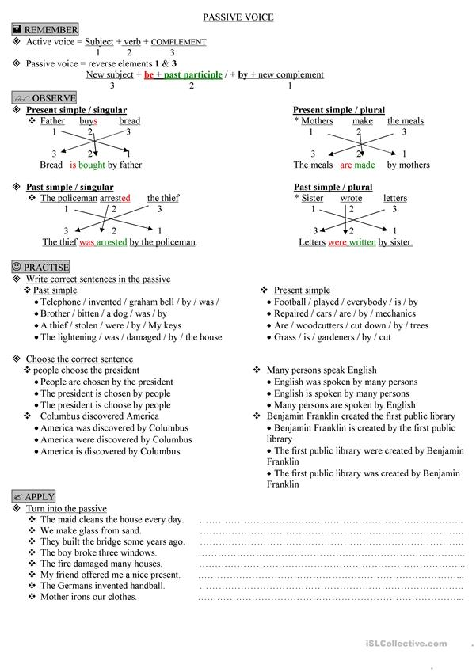

Read the text and decide if the statements below are TRUE or FALSE.

The Simpsons is an American animated sitcom starring the animated Simpson family, which was created by Matt Groening. The characters were conceived in the lobby of James L. Brooks's office and were named them after his own family members, substituting "Bart" for his own name. The family debuted as shorts on The Tracey Ullman Show on April 19, 1987. After a three-season run, the sketch was developed into a half-hour prime time show called The Simpsons. The show was first released on December 17, 1989. The show was an early hit for Fox and was awarded lots of prizes.

The show was considered controversial from its beginning. In the early seasons Bart was characterized as a poor role model for children by parents and conservative people. The Simpsons merchandise and t-shirts were banned by several United States public schools.

In January 1992, then-current President George H. W. Bush made a speech during his re-election in which he said: "We are going to keep on trying to strengthen the American family, to make American families a lot more like the Waltons and a lot less like the Simpsons". In 2002, the show was nearly sued by the Rio de Janeiro tourist board for creating an unreal image of the city on the show.

1. The Simpsons was created by James L. Brooks.
2. The show was created in 1989.
3. The show was considered polemic.
4. The animated series was never awarded a prize.
5. Bart was considered an excellent role model.
6. The characters were named after James brook’s relatives.
7. The Simpsons merchandise was sold in many schools.
8. The tv show was congratulated by the city of Rio de janeiro.

Que ejemplos de passive voice pudo observar en la lectura de los Simpsons y cual sería la traducción de estos en español?

________________________________________________________________________________________________________________________________________________________________________________________________________________________________________________________________________________________________________________________________________________________________________________________________________________________________________________________________________________________________________________________________________________________________________________________________________________________________________________________________________________________________________________________________________________________________________________________________________________________________________________________________________

Si tiene dudas l@ invito a consultar los siguientes links de refuerzo, contactarme por medio de mi correo o WhatsApp (3214485456).

<https://www.youtube.com/watch?v=LB9quANyVBc>

<https://www.youtube.com/watch?v=080leytixWE>

<https://www.youtube.com/watch?v=7glMZfnKVoA>

Por favor enviar la guía desarrollada a:

[mestefannic@educacionbogota.edu.co](mailto:mestefannic@educacionbogota.edu.co)