|  |  |  |  |
| --- | --- | --- | --- |
| DOCENTE | HARVEY LATORRE CASTRO | | |
| ESTUDIANTE |  | | |
| CURSO | OCTAVO | FECHA ENTREGA |  |

***a/an/some***

***Grammatical explanation:***

**a/an** are used when we need to say the name of one element. The key here, is to keep in mind if the word starts by a consonant, you have to use ***a*. Example: a** cat**, *a*** door**, *a*** bed, etc.

If the word starts by a vowel, you must to use ***an.* Example: *an*** apple, ***an*** e-mail, ***an*** Indian, etc.

***some*** is used when we need to say the name of **two or more elements. Example: *some*** cars, some beds, some apples, etc.

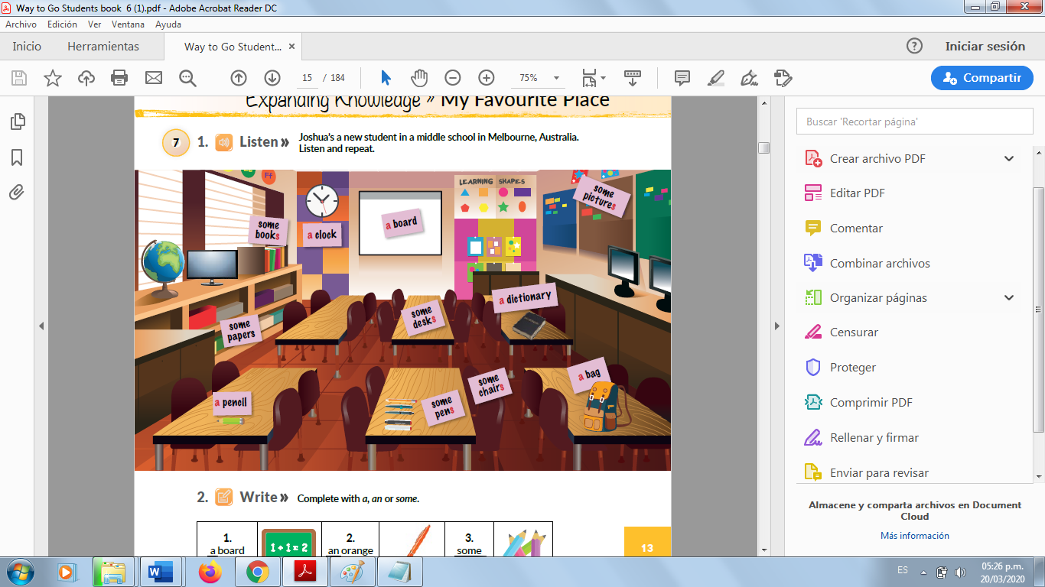

***There is/There are***

**Look at the picture above and answer the following questions. use *there is*** or ***there are*. Follow the example.**

**Example:**

**-How many boards *are there* in the classroom? *There is* one board in the classroom**

**1**. How manyscreens ***are there*** in the classroom? **__________________________________**

**2.** How manypencils ***are there*** on the tables? ________________________________

3. How many chairs can you see (***are there***) in the classroom? _______________________________

4. How many bags ***are there*** on that table? ____________________________

5. How many earth globes ***are there***? _________________________

6. How many pens can you see (***are there***)? _______________________

7. How many tables ***are there*** into the classroom? __________________________

8. How many dictionaries ***are there*** on the table? _________________________

**Complete with *a, an* or *some*.**

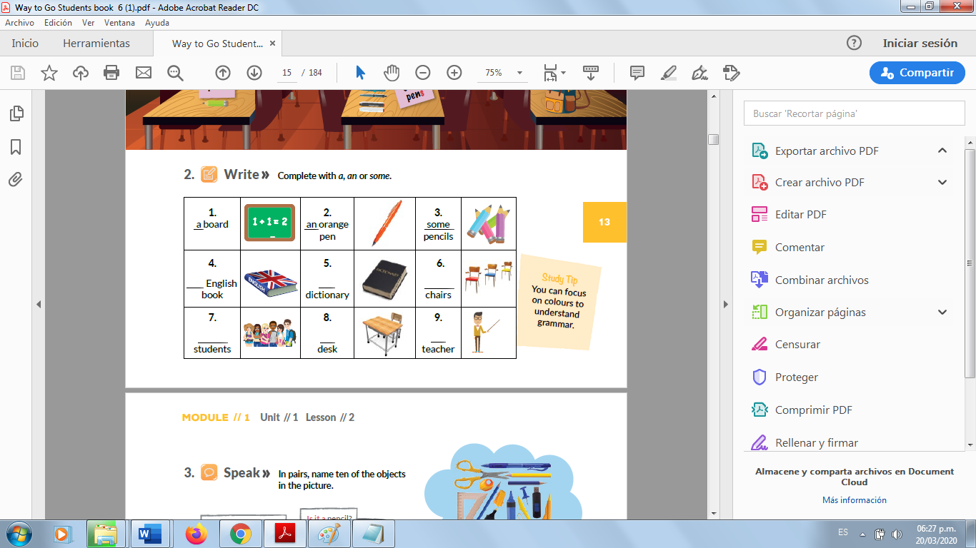

Read and tick (✔) the items mentioned in the text.

