|  |  |  |  |
| --- | --- | --- | --- |
| DOCENTE | Nancy Janneth Acosta Tocasuche (njacosta@hotmail.com) | | |
| ESTUDIANTE |  | | |
| CURSO | Transición 01 | FECHA ENTREGA | SEMANA 2 |

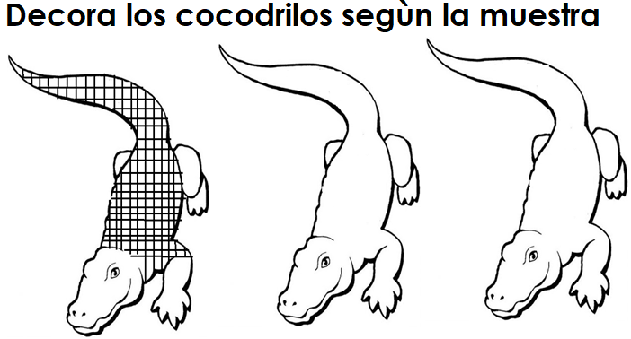

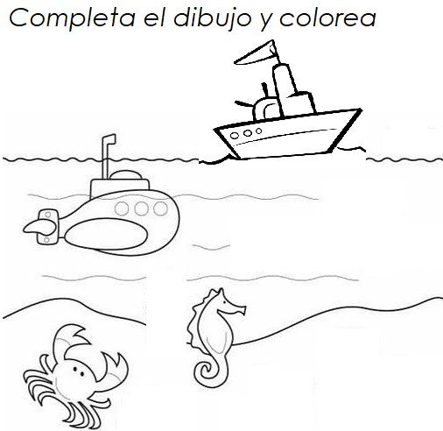

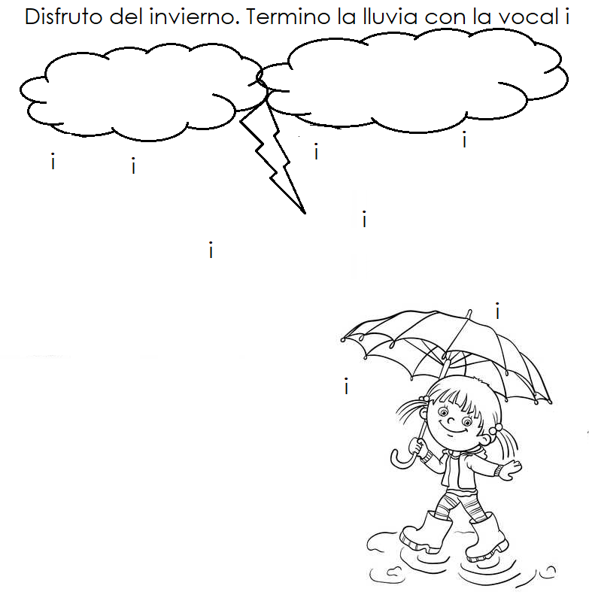

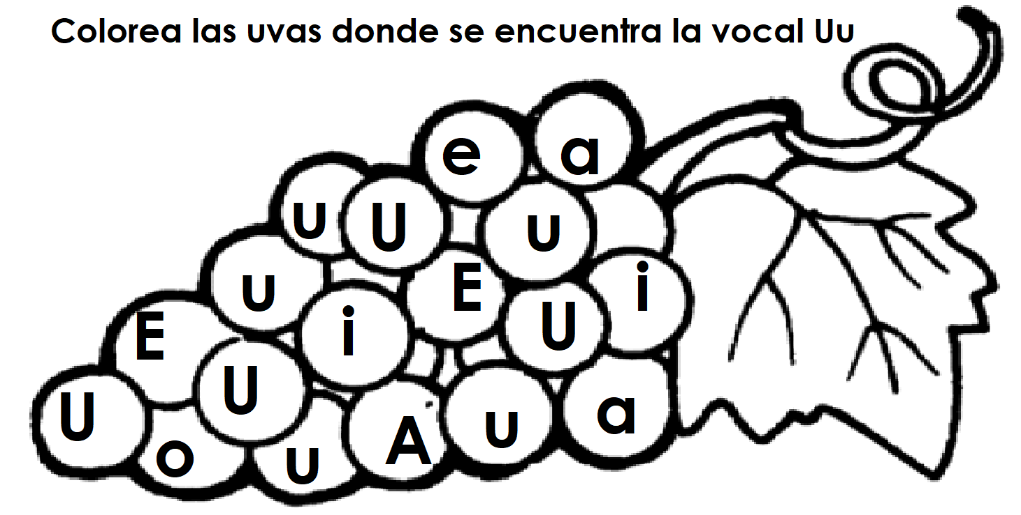

Escribe tu nombre:

|  |  |  |  |
| --- | --- | --- | --- |
| DOCENTE | Nancy Janneth Acosta Tocasuche (njacosta@hotmail.com) | | |
| ESTUDIANTE |  | | |
| CURSO | Transición 01 | FECHA ENTREGA |  |

