|  |  |  |  |
| --- | --- | --- | --- |
| DOCENTE | Daniel pardo | | |
| ESTUDIANTE |  | | |
| CURSO | tercero | FECHA ENTREGA |  |

**Email: dpardov@educacionbogota.edu.co**

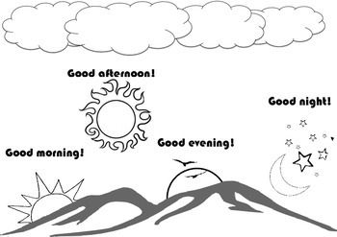

**EXERCISE: Look at the pictures and label them using the phrases in the box**

**Mira las imágenes y marcalas usando las frases del recuadro.**

|  |
| --- |
| **Good morning / good night / good evening / good afternoon /** |

|  |  |
| --- | --- |
|  |  |
|  |  |
|  |  |
|  |  |

**Ve al link y escucha la canción, luego practicarla varias veces hasta aprenderla**

[**https://www.youtube.com/watch?v=gVIFEVLzP4o**](https://www.youtube.com/watch?v=gVIFEVLzP4o)

**I am Spiderman**

**What’s your name?**

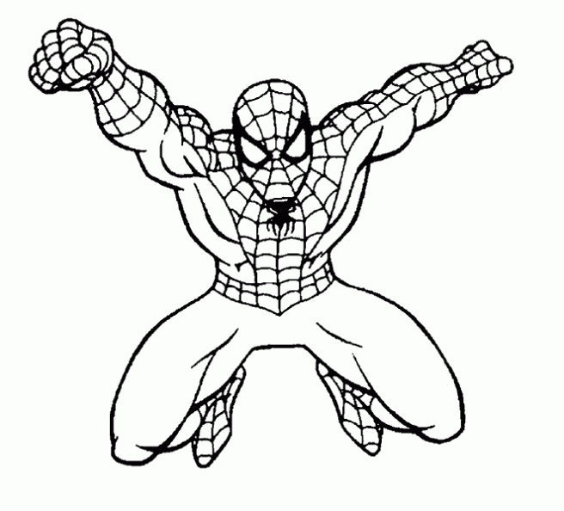

**Complete los espacios usando el nombre de los personajes, en el ultimo recuadro dibuja tu imagen y escribe tu nombre como en los demas ejemplos.**

|  |  |
| --- | --- |
| My name is ________________________ | I am __________________ |

**Complete the comic asking questions like** *What’s your name? and greetings.*

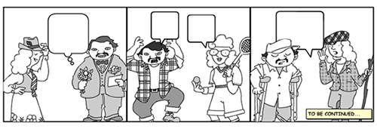

**Script**

**Complete the comic using a similar script to the following one.**

**Person 1: hello, good morning**

**Person 2: Hi**

**person 1: what’s your name?**

**person 2: My name is Janeth , what’s your name?**

**person 1 My name is Peter. nice to meet you**

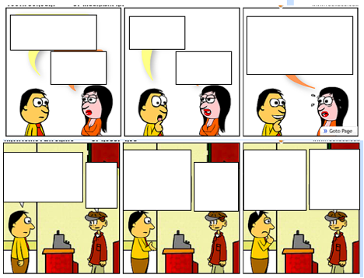

**Creating my own comic**

**Creo mi propia historieta.**

|  |  |  |  |
| --- | --- | --- | --- |
|  |  |  |  |
|  |  |  |
|  |  |  |  |