|  |  |  |  |
| --- | --- | --- | --- |
| DOCENTE | Daniel Pardo | | |
| ESTUDIANTE |  | | |
| CURSO |  | FECHA ENTREGA |  |

Email: dpardov@educacionbogota.edu.co

COMMANDS

1. 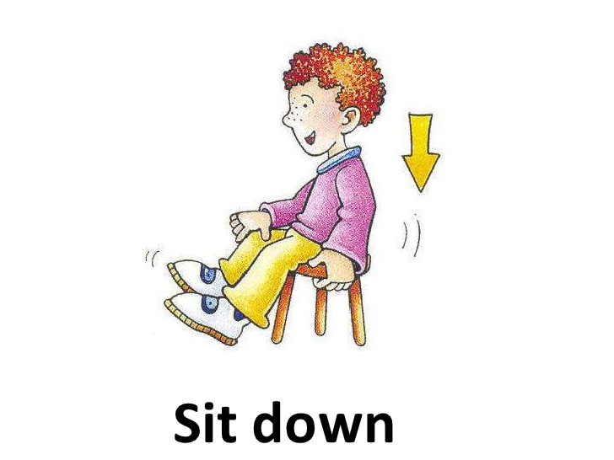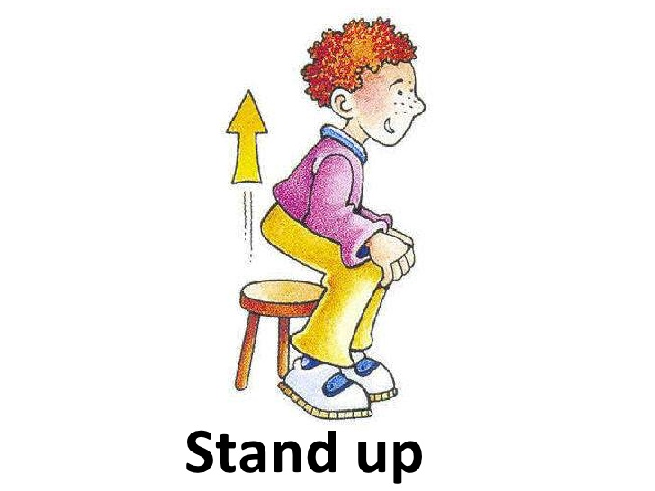**LEE REPITE Y LUEGO ESCRIBE**

STAND UP

SIT DOWN

___________________________________________ ___________________________________________

___________________________________________ ___________________________________________

___________________________________________ ___________________________________________

___________________________________________ ___________________________________________

___________________________________________ ___________________________________________

___________________________________________ ___________________________________________

___________________________________________ ___________________________________________

___________________________________________ ___________________________________________

___________________________________________ ___________________________________________

___________________________________________ ___________________________________________

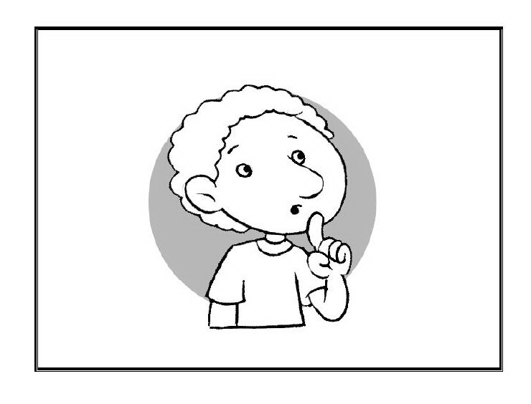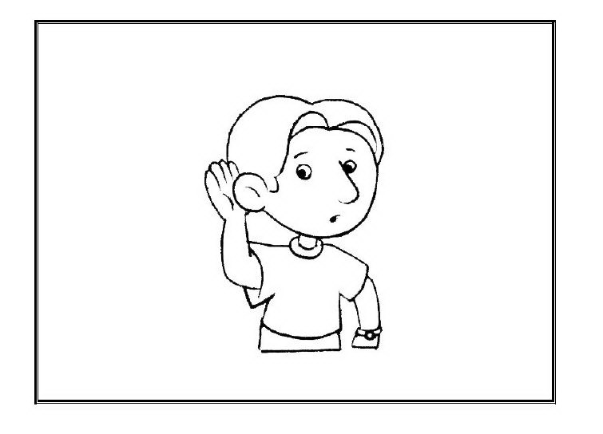

SILENT

LISTEN

___________________________________________ ___________________________________________

___________________________________________ ___________________________________________

___________________________________________ ___________________________________________

___________________________________________ ___________________________________________

___________________________________________ ___________________________________________

___________________________________________ ___________________________________________

___________________________________________ ___________________________________________

___________________________________________ ___________________________________________

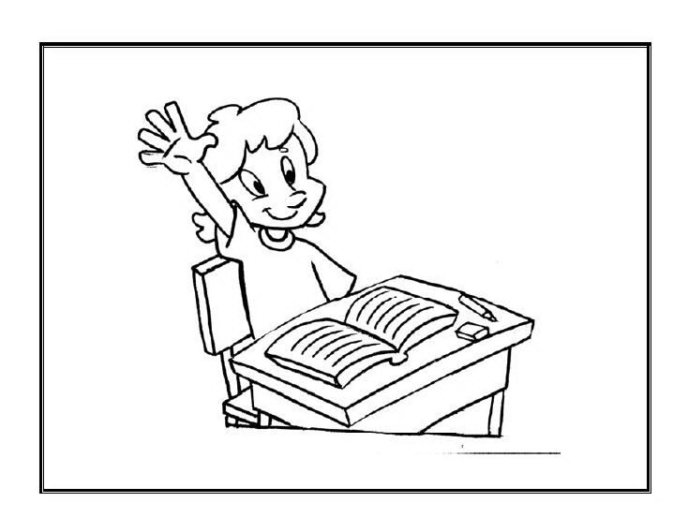

RISE YOUR HAND

__________________________________________________

__________________________________________________

__________________________________________________

__________________________________________________

__________________________________________________

__________________________________________________

__________________________________________________

__________________________________________________

1. **MATCH**

**UNE CON UNA LINEA LAS IMÁGENES DE LA IZQUIERDA CON LAS PALABRAS DE LA DERECHA SEGÚN CORRESPONDA**



STAND UP



SIT DOWN

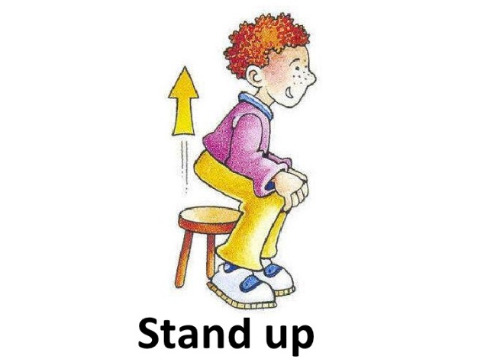

RISE YOUR HAND



SILENT



LISTEN