|  |  |  |  |
| --- | --- | --- | --- |
| DOCENTE | LAURA LEÓN UNIVIO, [ljleon@educacionbogota.edu.co](mailto:ljleon@educacionbogota.edu.co) | | |
| ESTUDIANTE |  | | |
| CURSO | 202 – J.M. | FECHA ENTREGA | 23 de Marzo/2020 |

**GUIA DE TRABAJO MATEMÁTICAS**

1. Escribe el nombre de los siguientes números:

* 50 ___________________________
* 42 ___________________________
* 15 ___________________________
* 38 ___________________________
* 25 ___________________________

1. Escribe las secuencias como se indica:
2. De 2 en 2 hasta 100.

_________________________________________________________

_________________________________________________________

_________________________________________________________

1. De 5 en 5 hasta 200.

_________________________________________________________

_________________________________________________________

_________________________________________________________

1. De 10 en 10 hasta 300.

_________________________________________________________

_________________________________________________________

_________________________________________________________

1. De 3 en 3 hasta 100.

_________________________________________________________

_________________________________________________________

_________________________________________________________

1. Ordena según se indica:

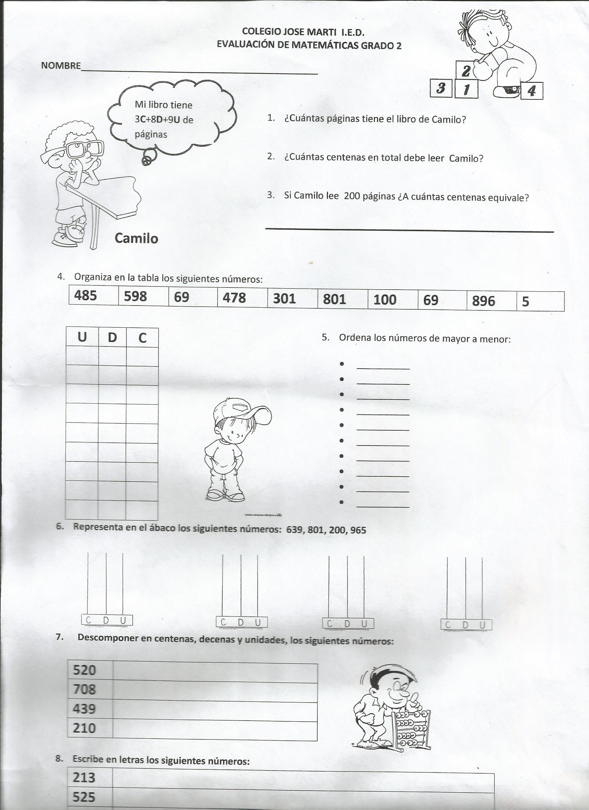

100 – 25 – 42 – 150 – 82 – 10 – 30

Menor a mayor:

15 – 120 – 78 – 92 – 60 – 25 – 32

Mayor a menor:

1. Unir con el número correspondiente:

* Cincuenta y dos 72
* Ciento veinte 98
* Doscientos 120
* Noventa y ocho 52
* Setenta y dos 200

1. Representa en el ábaco los siguientes números: 325, 150, 200, 350
2. Descomponer en decenas y unidades, los siguientes números:



|  |  |  |
| --- | --- | --- |
| Números | Decenas | Unidades |
| 82 |  |  |
| 43 |  |  |
| 50 |  |  |
| 15 |  |  |
| 32 |  |  |

1. Escriba los números del 1 al 100, en la siguiente tabla:

|  |  |  |  |  |  |  |  |  |  |
| --- | --- | --- | --- | --- | --- | --- | --- | --- | --- |
|  |  |  |  |  |  |  |  |  |  |
|  |  |  |  |  |  |  |  |  |  |
|  |  |  |  |  |  |  |  |  |  |
|  |  |  |  |  |  |  |  |  |  |
|  |  |  |  |  |  |  |  |  |  |
|  |  |  |  |  |  |  |  |  |  |
|  |  |  |  |  |  |  |  |  |  |
|  |  |  |  |  |  |  |  |  |  |
|  |  |  |  |  |  |  |  |  |  |
|  |  |  |  |  |  |  |  |  |  |

1. Descomponer en centenas, decenas y unidades, los siguientes números:

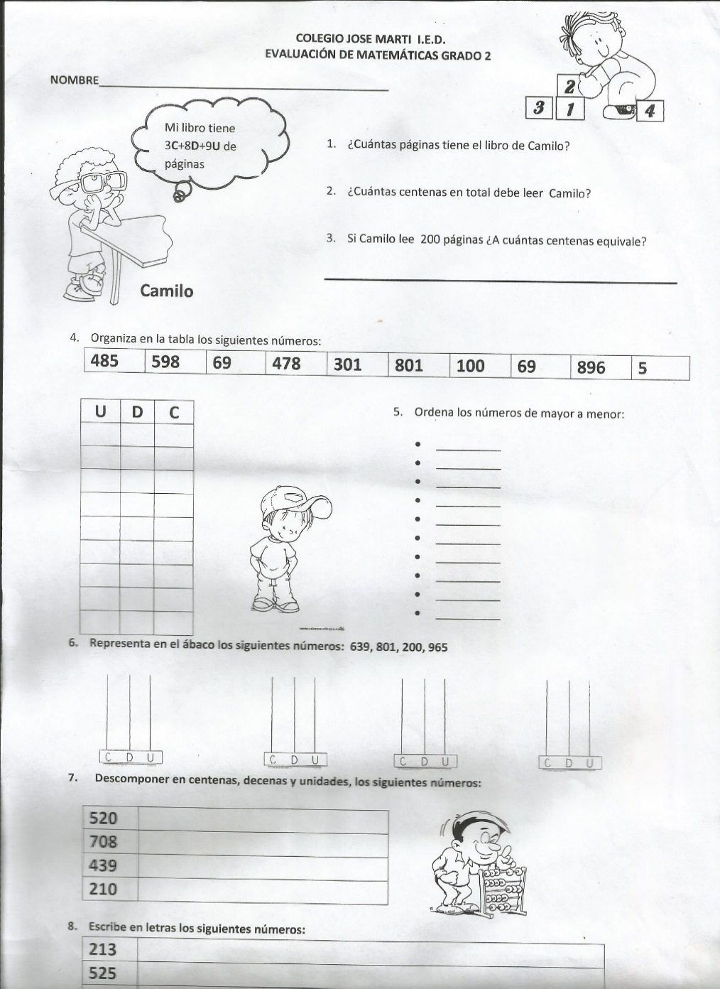

|  |  |  |  |
| --- | --- | --- | --- |
| Números | Centenas | Decenas | Unidades |
| 520 |  |  |  |
| 708 |  |  |  |
| 439 |  |  |  |
| 210 |  |  |  |
| 120 |  |  |  |

1. Realiza las siguientes sumas:

81

13

+

+

32

21

+

70

29

+

45

53

* 8 + 5 =
* 9 + 6 =
* 7 + 7 =
* 6 + 5 =

44

15

-

72

50

-

95

63

-

86

73

-

* 3 + 3 =
* 9 + 8 =
* 5 + 5 =