|  |  |  |  |
| --- | --- | --- | --- |
| DOCENTE | Daniel Pardo Vásquez | | |
| ESTUDIANTE |  | | |
| CURSO | cuarto | FECHA ENTREGA |  |

Email: dpardov@educacionbogota.edu.co

**1.Write the negative of the following sentences.**

1. She is my best friend. ……………………………………………………………….
2. They are very nice. …………………………………………………………………….
3. We are students. ………………………………………………………………………..
4. I am 20 years old. ………………………………………………………………………
5. He is a policeman. ……………………………………………………………………….
6. You are in the shop. ……………………………………………………………………
7. It is a big cat. ……………………………………………………………………………..
8. Peter and I are happy. ………………………………………………………………
9. Jane and Susan are doctors. ……………………………………………………
10. They are at school. …………………………………………………………………….

**2. Complete with AM, ARE or IS to form interrogative sentences.**

1. ……………………….it Monday?
2. ………………………they students?
3. ………………………I serious?
4. ………………………she at school?
5. ……………………..you a doctor?

**3.Write the interrogative of these sentences.**

1. They are very nice. ……………………………………………………………………..
2. She is tall. ……………………………………………………………………………………..
3. He is a doctor. ………………………………………………………………………………
4. We are happy. ……………………………………………………………………………….
5. I am hungry. …………………………………………………………………………………..

**4. Choose the correct answer.**

1) The bag (be) ________ blue.

A. am B. are C. is

2) It (be) ________ hard.

A. am B. are C. is

3) They (be) ________ young.

A. am B. are C. is

4) Thomas (be) ________ nice.

A. am B. are C. is

5) I (be) __________ a nurse.

A. am B. are C. is

**FOOD VOCABULARY**

**Busca en el diccionario la palabra en inglés correspondiente para cada comida.**

|  |  |  |  |  |
| --- | --- | --- | --- | --- |
| **hamburger.gif** | **sandwich.gif** | **bread.gif** | **soup.gif** | **fish.gif** |
|  |  |  |  |  |
| **milk.gif** | **cheese.gif** | **eggs.gif** | **chips.gif** | **meat.gif** |
|  |  |  |  |  |

**Decifra cada palabra, cada número representa una letra del abecedario (observa la imagen)**

|  |
| --- |
| RONAGE: --- --- --- --- --- --- ILMK: --- --- --- ---  15 17 1 14 8 6 13 10 12 11  CKICHNE: --- --- --- --- --- --- --- ECEHSE: --- --- --- --- --- ---  3 9 10 3 11 6 14 3 9 6 6 18 6  PALEP: --- --- --- --- --- ROTCRA: --- --- --- --- --- ---  1 16 16 12 6 3 1 17 17 15 19  CYERLEC: --- --- --- --- --- --- --- SIHF: --- --- --- ---  17 6 3 21 3 12 6 7 10 18 9  DREAB: --- --- --- --- --- SGARPE: --- --- --- --- --- ---  2 17 6 1 5 8 17 1 16 6 18  ASNDWCIHSE: --- --- --- --- --- --- --- --- --- ---  18 1 14 5 20 10 3 9 6 18  KECA: --- --- --- --- ANBAANS: --- --- --- --- --- --- ---  3 1 11 6 2 1 14 1 14 1 18  TAEVEGLBSE: --- --- --- --- --- --- --- --- --- --- RUFIST:--- --- --- --- --- ---  22 6 8 6 19 1 2 12 6 18 7 17 23 10 19 18  MESSAGE:  --- --- --- --- --- --- --- --- --- --- --- --- --- --- --- --- --- --- --- --- --- --- --- --- .  13 21 7 1 22 15 23 17 10 19 6 7 15 15 5 10 18 3 9 10 3 11 6 14    --- --- --- --- --- --- --- --- ---- --- --- ---- ---- ---- ---- ---- !  10 12 10 11 6 9 6 1 12 19 9 21 7 15 15 5  ---- ---- ---- ---- ---- ---- ---- ---- ---- ---- ----- -----?  5 15 21 15 23 17 6 3 21 3 12 6 |

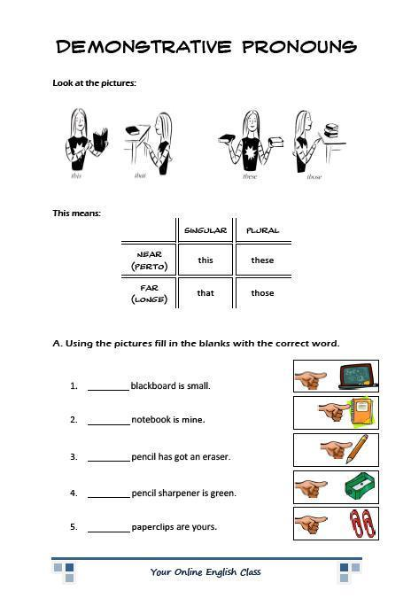

**DEMONSTRATIVE PRONOUNS:** Los pronombres demostrativos son THIS, THAT, THOSE Y THESE, los cuales permiten sealar y mencionar al objeto. THIS se usa para un solo objeto que se encuentre cerca, mientras que THAT se usa para un objeto lejos THESE se usa para varios objetos cerca y THOSE para varios objetos lejos. (THIS>este, esta) (THAT > ese, esa) (THESE estos, estas) (THOSE> esos, esas).

|  |
| --- |
| ANd9GcQGKOOPKqm9scK62ZLvcjJRkKzh5B3yCuO0tMY1yO1qQrI97yPsxACardboard Box Clip Art ANd9GcQGKOOPKqm9scK62ZLvcjJRkKzh5B3yCuO0tMY1yO1qQrI97yPsxA Cardboard Box Clip ArtCardboard Box Clip Art  ___________________________ _________________________  ANd9GcQGKOOPKqm9scK62ZLvcjJRkKzh5B3yCuO0tMY1yO1qQrI97yPsxA http://images.clipartpanda.com/pig-clip-art-KijyR7eiq.png ANd9GcQGKOOPKqm9scK62ZLvcjJRkKzh5B3yCuO0tMY1yO1qQrI97yPsxA http://images.clipartpanda.com/pig-clip-art-KijyR7eiq.pnghttp://images.clipartpanda.com/pig-clip-art-KijyR7eiq.png  ________________________ _________________________  ANd9GcQGKOOPKqm9scK62ZLvcjJRkKzh5B3yCuO0tMY1yO1qQrI97yPsxA http://cdn5.fotosearch.com/bthumb/ARP/ARP113/Watch.jpg ANd9GcQGKOOPKqm9scK62ZLvcjJRkKzh5B3yCuO0tMY1yO1qQrI97yPsxA http://cdn5.fotosearch.com/bthumb/ARP/ARP113/Watch.jpg http://cdn5.fotosearch.com/bthumb/ARP/ARP113/Watch.jpg  _______________________ ____________________________  ANd9GcQGKOOPKqm9scK62ZLvcjJRkKzh5B3yCuO0tMY1yO1qQrI97yPsxA  ANd9GcQGKOOPKqm9scK62ZLvcjJRkKzh5B3yCuO0tMY1yO1qQrI97yPsxA |