|  |  |  |  |
| --- | --- | --- | --- |
| DOCENTE | LILIANA ARTEAGA | | |
| ESTUDIANTE |  | | |
| CURSO | 604 | FECHA ENTREGA |  |
| E-MAIL | ilarteaga@educacionbogota.edu.co | | |

1. **Read and write the number. Don’t forget commas!**
2. Four __________________________________
3. Twelve ________________________________
4. Twenty three___________________________
5. Fifty six________________________________
6. Seventy one ____________________________
7. One hundred and seven___________________
8. Three hundred and eighteen _______________
9. Five hundred and forty____________________
10. Nine hundred and thirty one ________________
11. Two thousand and nineteen __ _____________
12. Three thousand one hundred and seventy one___________________________________
13. Fourteen thousand five hundred and twelve_________________________________
14. Sixty three thousand eight hundred and ninety ______________________________________
15. Two hundred thousand nine hundred and forty six ______________________________________
16. One million and nine ______________________________________
17. Two millios and fifteen ____________________
18. Three million and fifty two _________________
19. Six million two hundred thousand three hundred and fourteen ____________________________
20. Twenty million three hundred and sixty one thousand seven hundred and twenty nine ______________________________________
21. Two hundred million one hundred and ninety three thousand five hundred and fifty eight ______________________________________

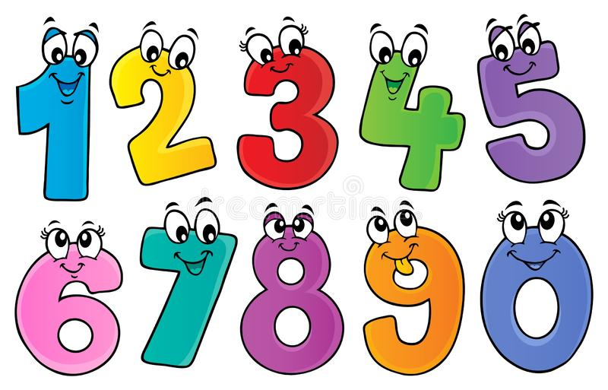

1. **Complete the conversations.**

**Teacher:** Good morning Class.

**Students: __________________________________**

**Teacher:** How are you?

**Students: __________________________________**

**Teacher:** I’m fine, thank you.

**Peter:** Hello Ann

**Ann: Hi Peter. _______________________?**

**Peter:** I’m fine, thank you? **__________________?**

**Ann:** I’m fine, thank you.

**Peter:** This is my friend Susan.

**Ann: ____________________________** Susan.

**Susan:** Nice to meet you too.

**Peter: ___________________** Ann

**Ann:** Bye Peter and Susan.

**Louis:** Is this pencil yours?

**Mary:** Yes, It’s mine**. ________________________**

**Louis:** You’re welcome.

**Katie: _______________,** teacher.

**Teacher:** Hello Katie, how are you today?

**Katie**: I’m __________. _____________. And you?

**Teacher:** I’m fine.

**Katie: ________** bye, teacher**.**

**Teacher:** See you later, Katie.

