**GUÍA No. 7 – INTERDISCIPLINAR (BACHILLERATO – PRIMARIA)**

**GRADO:** **9°**

|  |  |  |  |
| --- | --- | --- | --- |
| **DOCENTE** | **GRUPO** | **E-MAIL** | |
| Liliana Arteaga | 901, 902 y 903 | **ilarteaga@educacionbogota.edu.co** | |
|  |  |  | |
| **TEMA** | **First conditional** | | | |
| **OBEJTIVOS** | | **INDICADOR (ES) DE DESEMPEÑO:** | | |
| * **Comprender la información implícita en textos relacionados con temas de interés.** * **Producir textos sencillos con diferentes funciones a saber: descriptivas, narrativas y argumentativas sobre temas personales y/o situaciones reales o imaginarias.** * **Expresar sus ideas sobre temas trabajados en clase a través de diálogos y/o dramatizaciones en forma individual o grupal** | | 1. Solicita y brinda información sobre experiencias de manera breve y clara. 2. Explica por escrito, de forma coherente y sencilla situaciones y hechos que le son familiares. 3. Reconoce información específica en textos cortos orales y escritos sobre temas de interés general. 4. Demuestra interés y responsabilidad en clase | | |
| **AREAS - ASIGNATURAS INVOLUCRADAS:**  **Inglés** | | | **PRODUCTO A ENTREGAR**   * Guía desarrollada en el cuaderno o en hojas. * Resuelve los ejercicios en línea de Agenda web y envía la captura de pantalla al correo del docente. | |

**ACTIVIDADES:**

|  |
| --- |
| **FECHA DE DESARROLLO:** |
| **ACTIVIDAD**   * **En el momento de enviar la guía recuerda lo siguiente:** * Debes Escribir un pequeño correo de presentación que incluya: saludo para el maestro a quien va dirigido tu trabajo; identificación completa con nombres y apellidos y el curso al cual perteneces. * El desarrollo de la guía se envían únicamente al correo institucional de cada docente (aparece en el encabezado de la guía). |

**FIRST CONDITIONAL**



**The first conditional is used to express a real or very probable situation in the future. It is common when we are talking about possible plans, promises, warnings, threats or for persuading someone.**

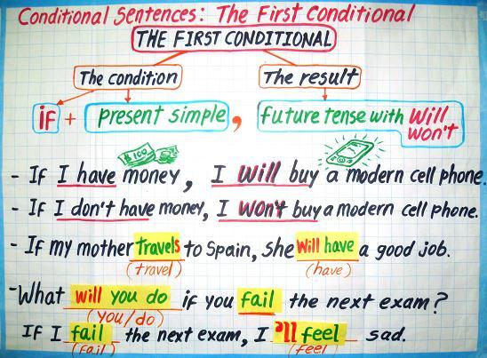

**Examples**

* If it **rains**, I **won't go** to the park.
* If I **study** today, I**'ll go** to the party tonight.
* If I **have** enough money, I**'ll buy** some new shoes.
* She**'ll be** late if the train **is** delayed.
* She**'ll miss** the bus if she **doesn't leave** soon.
* If I **see** her, I**'ll tell** her.



Watch the video about First conditional to reinforce the topic.

**Click here**

<https://www.youtube.com/watch?v=hT5PWuuxaKM>





**Exercise 1. Match the columns. Fill in the blanks with the corresponding letter.**

1. If I have time, **_____** **a.** your headache won’t dissappear.
2. If we don’t hurry, **_____**  **b.** if you don’t work tomorrow?
3. If you pay now, **_____**  **c.** I will buy some fruits.
4. I will have more money**_____**  **d.** I’ll visit my parents this afternoon.
5. He won’t pass the exam **_____**  **e.** if he doesn’t find the tickets.
6. She will be angry, **_____**  **f.** You’ll get a discount.
7. If you don’t take an aspirin, **_____** **g.** We will miss our bus.
8. My uncle won’t go to the opera **_____** **h.** if he doesn’t study.
9. What will happen **_____**  **i.** if I get a good job.
10. If I go to the supermarket, **_____** **j.** if I don’t call her today.

**Exercise 2. Write the complete sentences above, then match the pictures with the sentences, write the number inside the circle.**

|  |
| --- |
| SENTENCES (FIRST CONDITIONAL) |
|  |
|  |
|  |
|  |
|  |
|  |
|  |
|  |
|  |
|  |

  

   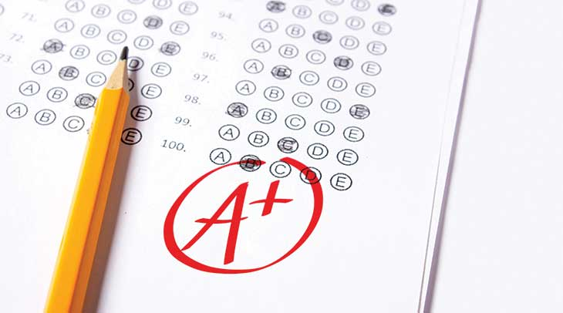

  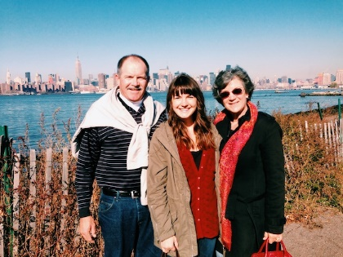

**Exercise 3. Answer the following questions using first conditional. Use complete statements.**

1. What will you do if you lost your phone?

____________________________________

1. If you feel bored next Saturday, what will you do?

____________________________________

1. What medicine will you take if you catch a cold?

____________________________________

1. What will you do if the lockdown ends?

____________________________________

**Exercise 4. Choose the correct answer.**

1. If Lucy has a tootache tomorrow, will he visit the dentist?
2. Yes, she will the dentist. **/** **b.** No, she won’t visit the dentist
3. If Patrick doesn´t understand his homework, what will he do?
4. He won’t do his homework. **/**  **b.** He will ask the teacher for help.
5. If you study English everyday, will you learn more?
6. Yes, I will learn more. **/** **b.** No, I won’t learn more.
7. If the weather is nice tomorrow, what will you do?
8. We will stay at home. **/ b.** We will go to the beach.
9. If you don’t work, will you be a succesful person?
10. Yes, I will be succesful person **/** **b.** No, I won’t be a succesful person.

**Exercise 5. Solve online exercises in Agenda Web about “First conditional”.**

**Please send me the screenshot to my email.**

**Click here**

<https://agendaweb.org/exercises/verbs/conditional/first-conditional-1>

<https://agendaweb.org/exercises/verbs/conditional/first-negative-questions>

<https://web2.uvcs.uvic.ca/courses/elc/studyzone/330/grammar/1cond1.htm>

