**GUÍA No. 7**

**– INTERDISCIPLINAR (BACHILLERATO – PRIMARIA)**

**GRADO:** **8°**

|  |  |  |  |
| --- | --- | --- | --- |
| **DOCENTE** | **GRUPO** | **E-MAIL** | |
| Liliana Arteaga | 804 | **ilarteaga@educacionbogota.edu.co** | |
| Harvey Latorre | 801, 802 y 803 | **ralatorre@educacionbogota.edu.co** | |
|  |  |  | |
| **TEMA** | **Simple present tense, Healthy habits and Can – Can’t** | | | |
| **OBEJTIVOS** | | **INDICADOR (ES) DE DESEMPEÑO:** | | |
| * **Comprender la información implícita en textos relacionados con temas de interés.** * **Producir textos sencillos con diferentes funciones a saber: descriptivas, narrativas y argumentativas sobre temas personales y/o situaciones reales o imaginarias.** * **Expresar sus ideas sobre temas trabajados en clase a través de diálogos y/o dramatizaciones en forma individual o grupal** | | 1. Solicita y brinda información sobre experiencias de manera breve y clara. 2. Explica por escrito, de forma coherente y sencilla situaciones y hechos que le son familiares. 3. Reconoce información específica en textos cortos orales y escritos sobre temas de interés general. 4. Demuestra interés y responsabilidad en clase | | |
| **AREAS - ASIGNATURAS INVOLUCRADAS:**  **Inglés** | | | **PRODUCTO A ENTREGAR**   * Guía desarrollada en el cuaderno o en hojas. * Esta vez, no es necesario que envíes los pantallazos de los ejercicios online de Agenda web, pero si te es posible, resuélvelos para practicar el tema. | |

**ACTIVIDADES:**

|  |
| --- |
| **FECHA DE DESARROLLO:** |
| **ACTIVIDAD**  **En el momento de enviar la guía recuerda lo siguiente:**  **Debes Escribir un pequeño correo de presentación que incluya: saludo para el maestro a quien va dirigido tu trabajo; identificación completa con nombres y apellidos y el curso al cual perteneces.**  **Los desarrollos se envían únicamente al correo institucional de cada docente** (aparece en el encabezado de la guía). |

**SIMPLE PRESENT TENSE**

**DAILY ROUTINES**



**Recordemos las reglas del presente simple para la forma afirmativa, negativa e interrogativa.**

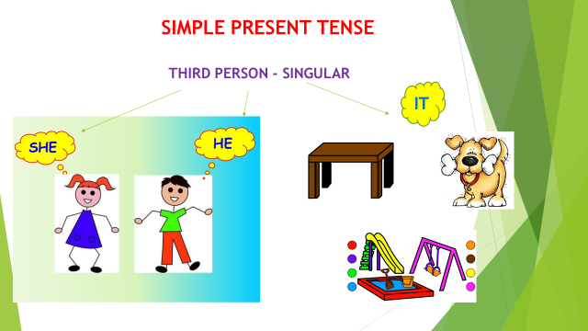 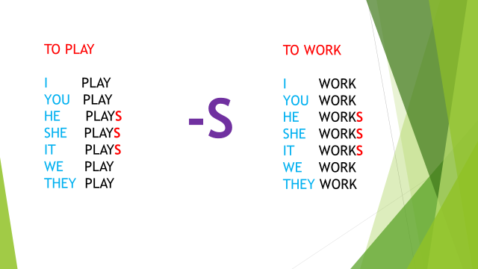

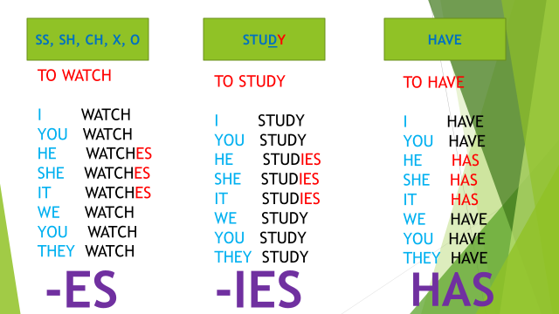

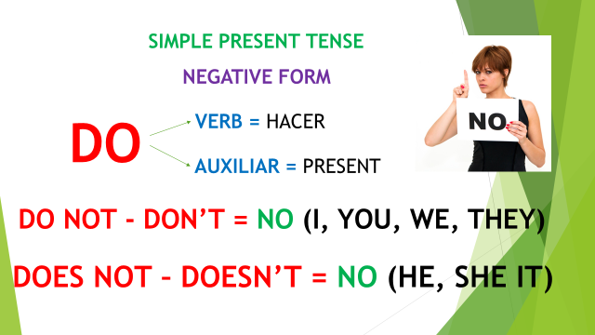 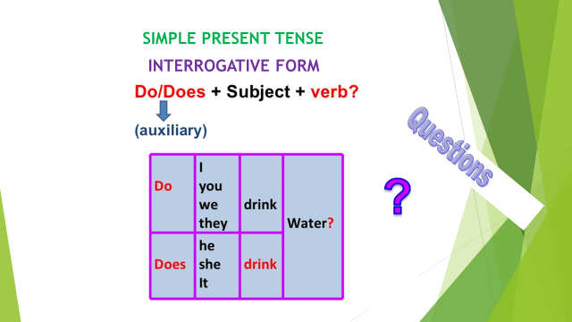

**Utilizamos los adverbios de frecuencia para indicar con qué frecuencia (“How often”) realizamos una determinada actividad o acción.**

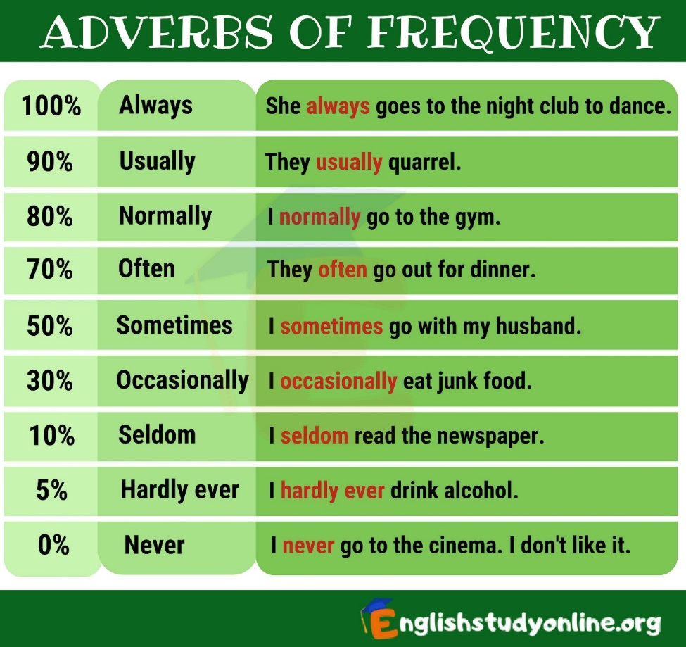

**Presta mucha atención y disfruta de los siguientes videos que te recordarán muy fácilmente el tema de los adverbios de frecuencia**. **(Frecuency adverbs).**

**Click here**

<https://www.youtube.com/watch?v=VpESOerMY7I&t=10s>

<https://www.youtube.com/watch?v=qG0N1TMtyDw>

 

* **Read the text. Adverbs of frequency.**

***First of all***, I **usually** wake up at 6 o’clock. ***Then*** I take a shower, I get dressed and I **often** put on make up. At 6:30 a.m. I have breakfast. I **always** leave home at 6:45 a.m. and take the bus to school. ***Next***, I attend classes from 8:00 a.m. to 1:00 p.m. ***Later***, I have lunch at 1:30 p.m. I **sometimes** eat some fruit. At 2:00 p.m. I go back home, I do my homework and house chores in the afternoon. I **rarely** watch TV. At 6:30 p.m. I read a book and listen to music. I **never** read the newspaper. At 7:30 p.m. I have dinner with my family. ***After that***, I brush my teeth and wash my face. ***Finally***, I **often** go to bed at 9:00 p.m.

**Exercise 1. Answer the questions based on the reading. How often…? (Cada cuánto…? o Con qué frecuencia…?)**

1. How often do you wake up at 6 o’clock?

___________________________________________________

1. How often do you leave home at 6:45 AM?

___________________________________________________

1. How often do you eat fruits?

___________________________________________________

1. How often do you watch TV?

___________________________________________________

**Answer the questions about your family.**

1. How often does your mom put on make up?

___________________________________________________

1. How often does your dad read the newspaper?

___________________________________________________

1. How often does your brother read a book?

___________________________________________________

1. How often does your sister go to bed at 7:00 PM?

___________________________________________________

**Exercise 2. Put in order the pictures that Lina does everyday.**

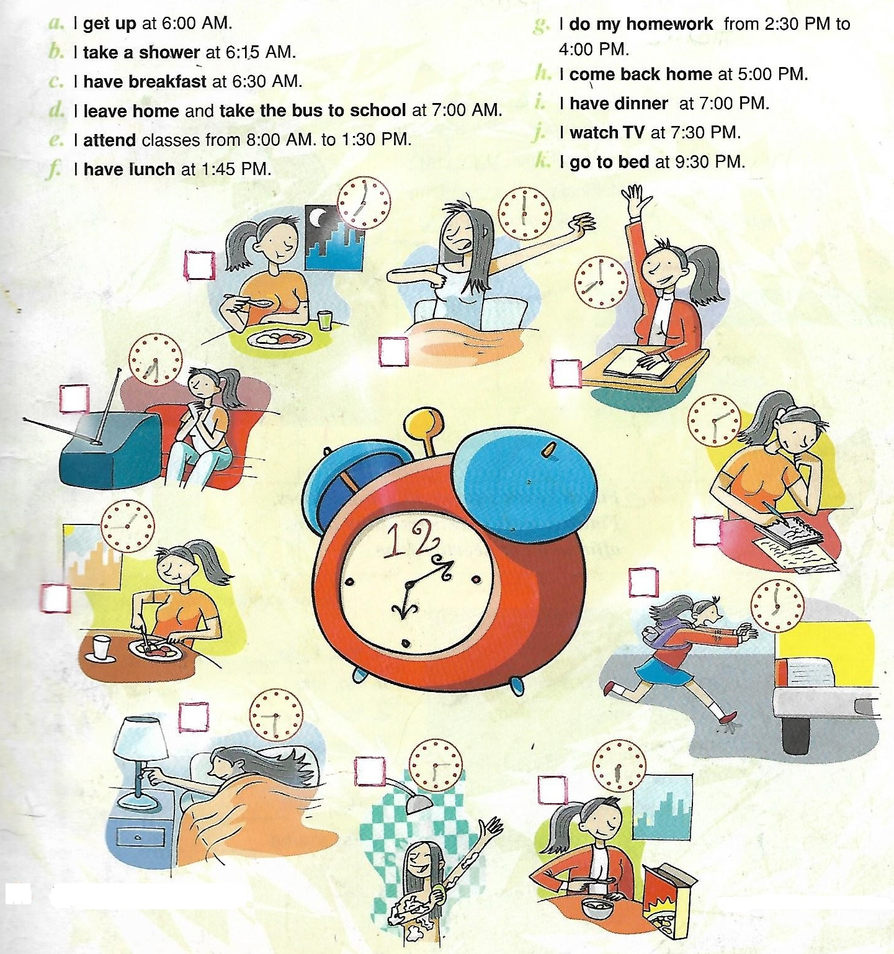

* **Read the following text.**

Juliana Da Silva lives in Rio de Janeiro, Brazil. She is fifteen. She studies at Colégio Estadual. Her father is a doctor and works at a hospital. Her mother is an engineer.

Everyday she gets up at 6:30 AM and goes to school. She is in the nineth grade. She has classes in the morning.

She arrives home at 1:00 PM . In the afternoon she does her homework and listens to music. She doesn’t watch TV at night. Finally, she goes to bed at 9:30 PM.

On weekends, she usually reads or goes to concerts or to the movies with her friends. She doesn’t go swimming. She loves music!

**Exercise 3. Answer the questions, based on the reading. Use complete sentences.**

1. Does Juliana study at José Martí High School?

________________________________________

1. Where does she study?

________________________________________

1. Does her father is a doctor?

________________________________________

1. What time does she gets up?

________________________________________

1. Does she watch TV at night?

**________________________________________**

**Exercise 4. Check True (T) or False (F) based on the reading.**

|  |  |  |
| --- | --- | --- |
| **Statements** | **T** | **F** |
| 1. She doesn’t go to school. |  |  |
| 1. She arrives home at 1:00 PM. |  |  |
| 1. In the afternoon she watches TV. |  |  |
| 1. She usually reads on weekends. |  |  |
| 1. She loves music. |  |  |
| 1. She goes swimming on weekends. |  |  |
| 1. She goes to bed at 1:00 PM. |  |  |
| 1. She doesn’t listen to music. |  |  |

**Exercise 5. Solve online exercises in Agenda Web about “Adverbs of frequency”.**

**Click here**

<https://agendaweb.org/exercises/grammar/adverbs/frequency-2>

<https://agendaweb.org/exercises/grammar/adverbs/frequency-3>

<http://www2.arnes.si/~oskplucija4/ces/howoften.htm>

