**GUÍA No. 7 – INTERDISCIPLINAR (BACHILLERATO)**

**GRADO:** __SEXTO__

|  |  |  |  |
| --- | --- | --- | --- |
| **DOCENTE** | **GRUPO** | **E-MAIL** | |
| NICOLAS MANRIQUE | 606,607,608 | [mestefannic@educacionbogota.edu.co](mailto:mestefannic@educacionbogota.edu.co) | |
| JAVIER HOYOS CAMACHO | 601,602 603 | jhoyosc@educacionbogota.edu.co | |
| LILIANA ARTEAGA | 604 | ilarteaga@educacionbogota.edu.co | |
| HARVEY LATORRE CASTRO | 605 | ralatorre@educacionbogota.edu.co | |
| **TEMA** | Likes and dislikes, Can and can’t, festivities and months of the year. | | |
| **OBJETIVOS** | | | **INDICADOR (ES) DE DESEMPEÑO:** |
| * Reconocer las estructuras para expresar gustos, habilidades o posibilidades. * Reconocer el vocabulario sobre celebraciones y meses del año. | | | * Identifica y utiliza las estruturas para preguntar o expresarse acerca de gustos habilidades o posibilidades. * Identifica y utiliza el vocabulario sobre festividades así como los meses del año. |
| **AREAS - ASIGNATURAS INVOLUCRADAS:**  **INGLÉS-CLUB DE INGLES** | | | **PRODUCTO A ENTREGAR: GUÍA 7** |

**Vocabulary:**

I like = ( me gusta) I dislike / I don´t like = ( no me gusta)

Do you like… ?= ( te gusta ….? ) do they like…? = ( a ellos les gusta?)

Does he like…?= ( A él le gusta…? ) Does she like…?= ( a ella le gusta..? )

What do you like to do in ……?= ( Qué te gusta hacer en……? )

I can = ( yo puedo) I can not ( can’t) = ( yo no puedo)

**MODAL VERB CAN**

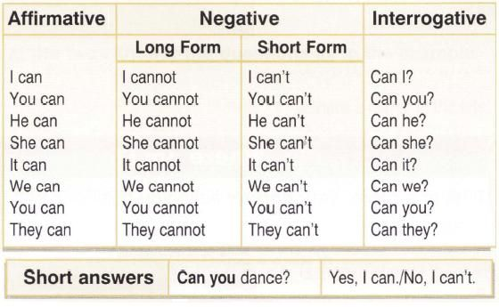

**1. Complete el texto con la correcta forma del verbo “like” puede utilizar las siguientes según corresponda ( like - likes – dislikes / don’t like - doesn´t like )**

Hello, my name is Alberto. After school, my brothers and I have a very good time. I___like_______

to do physical activities like riding a bike, but my brother Tomas 1 __________________________(not) to do other

types of activities. He 2__________________________ (not )to do exercise. Marco 3____________________(not) to

read. At 5:00 pm, Tomas 4______________________ to check his e-mail but he 5_____________________ to do homework. Some days, we all 6 __________________________________ to play video games. Mom 7 ___________________________ to make dinner at 6:30 pm, then we 8 _____________________________________(not) go to bed early because we 9_____________________ to watch TV until 11 pm.

**2. Lee el texto del ejercicio 2 nuevamente. Responde las siguientes preguntas acerca del texto.**

EXAMPLE: Does Alberto like to be in the house after school?  *No, he doesn’t. He likes to play sports*

**1.** Does Tomas like to do exercise?__________________________________________________________________

**2.** Does Marco like to read? ______________________________________________________________________

**3.** Do they play video games together?______________________________________________________________

**4.** Does Alberto cook dinner for his brothers?_________________________________________________________

**5.** Do they eat dinner before 8:00 pm?_______________________________________________________________

6. Does Alberto dislike to ride his bike? _____________________________________________________________

7. Do the brothers dislike to play video games ? _______________________________________________________

**3. Mira las fotos. Escribe oraciones acerca de los que la gente puede o no puede hacer usando (can-can’t)**



A B C



D E F

**1.** The girl in photo A _______can play basketball _____________________________________________

**2.** The woman in photo B _________________________________________________________________

**3.** The woman in photo C _________________________________________________________________

**4.** The boy in photo D ___________________________________________________________________

**5.** The girl in photo E ____________________________________________________________________

**6.** The boy in photo F ____________________________________________________________________

**4. Junta las festividades de la izquierda con los meses en los que estas se celebran en la columna de la derecha. Coloca la letra correspondiente al mes al frente de la festividad que se celebra. ( busca en el diccionario**

1. CHRISTMAS ______ A OCTOBER

2. HALLOWEEN ______ B. JANUARY

3. SAINT VALENTINE’S DAY ______ C. MARCH

4. MOTHER’S DAY ______ D. JULY

5. FATHER’S DAY ______ E. AUGUST

6. WOMEN’S DAY ______ F. NOVEMBER

7. CHILDREN’S DAY ______ G. MAY

8. INDEPENDENCE DAY ______ H. DECEMBER

9. LOVE AND FRIENDSHIP DAY (COLOMBIA) ______ I. APRIL

10. SPANISH LANGUAGE DAY _______ J. FEBRUARY

11. CARNIVAL OF BLACK AND WHITE ( NARIÑO) _________ K. JUNE

12. BATTLE OF BOYACÁ (COLOMBIA) _______ L. SEPTEMBER

5. Responde las siguientes preguntas en Inglés.

a. What do you like to do in Halloween? ___In halloween I like to ….__________________________________

b. What does your mother like to do in mother’s day? ____My mother likes to…______________________ ________________________________________________________________________________________

c. What do you like to do in children’s day? _________________________________________________________

d. What do you like to eat in December? ____________________________________________________________

e. What do you like to do in September? ____________________________________________________________

f. What can you do in August ? ____________________________________________________________________

g. What do you dislike about school? _______________________________________________________________

h. What can your parents do? _____________________________________________________________________

i. What do your parents dislike? ____________________________________________________________________

Si tiene dudas l@ invito a consultar los siguientes links de refuerzo:

Likes and dislikes: <https://www.youtube.com/watch?v=tidOxlj1T38>

Can and can’t: <https://www.youtube.com/watch?v=SeLYwHeOodM>

Months of the year: <https://www.youtube.com/watch?v=weGhyXqZg2c>