**GUÍA No. 5 – INTERDISCIPLINAR (BACHILLERATO)**

**GRADO:** **9°**

|  |  |  |  |
| --- | --- | --- | --- |
| **DOCENTE** | **GRUPO** | **E-MAIL** | |
| Liliana Arteaga | 901, 902 y 903 | **ilarteaga@educacionbogota.edu.co** | |
|  |  |  | |
|  |  |  | |
| **TEMA** | **Future tense “Be going to “** | | | |
| **OBEJTIVOS** | | **INDICADOR (ES) DE DESEMPEÑO:** | | |
| * **Comprender la información implícita en textos relacionados con temas de interés.** * **Producir textos sencillos con diferentes funciones a saber: descriptivas, narrativas y argumentativas sobre temas personales y/o situaciones reales o imaginarias.** * **Expresar sus ideas sobre temas trabajados en clase a través de diálogos y/o dramatizaciones en forma individual o grupal** | | 1. Solicita y brinda información sobre experiencias de manera breve y clara. 2. Explica por escrito, de forma coherente y sencilla situaciones y hechos que le son familiares. 3. Reconoce información específica en textos cortos orales y escritos sobre temas de interés general. 4. Demuestra interés y responsabilidad en clase | | |
| **AREAS - ASIGNATURAS INVOLUCRADAS:**  **Inglés** | | | **PRODUCTO A ENTREGAR**   * Guía desarrollada en el cuaderno o en hojas. * Pantallazos (screenshots) enviados al correo con los resultados finales de cada actividad en línea. | |

**ACTIVIDADES:**

|  |
| --- |
| **FECHA DE DESARROLLO:** |
| **ACTIVIDAD**  **En el momento de enviar la guía al correo, recuerda lo siguiente:**   * **Debes escribir un pequeño mensaje de presentación que incluya: saludo para el maestro a quien va dirigido tu trabajo; número de guía, identificación completa con nombres y apellidos y el curso al cual perteneces.** * **Los desarrollos se envían únicamente al correo institucional de cada docente** (aparece en el encabezado de la guía). |

**FUTURE TENSE (BE GOING TO)**

***Be going to*: uses**

*Be going to* is commonly used in informal styles.

Intentions

We use ***be going to*** to talk about future plans and intentions. Usually the decision about the future plans has already been made:

*She’****s going to****be a professional dancer when she grows up.*

*I’****m going to****look for a new place to live next month.*

Predictions

We use *be going to* to predict something that we think is certain to happen or which we have evidence for now:

*It’s****going to****snow again soon.* (The speaker can probably see dark snow clouds.)

*Look out! He****’s going to****break that glass.*

Commands

We use *be going to* when we give commands or state that something is obligatory:

[parent to a child]

*You’****re going to****pick up all of those toys right now. This room is a mess!*





Watch the video to reinforce grammar rules of “Be going to”

**Click here** <https://www.youtube.com/watch?v=0_-8yPyCDHI>

**EXAMPLES (BE GOING TO)**

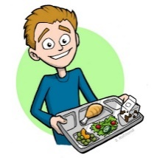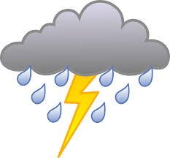**AFFIRMATIVE FORM**



I **AM GOING TO HAVE** LUNCH

YOU ARE **GOING TO TRAVEL** TO RUSSIA

HE **IS GOING TO BUY** A NEW CAR

SHE **IS GOING TO CLEAN** HER BEDROOM

IT **IS GOING TO RAIN**

WE **ARE GOING TO GO** TO SCHOOL

THEY **ARE GOING TO GET MARRIED**

**NEGATIVE FORM INTERROGATIVE FORM**

I **AM NOT GOING TO HAVE** LUNCH **AM** I  **GOING TO HAVE** LUNCH**?**

YOU **ARE** **NOT GOING TO TRAVEL** TO RUSSIA **ARE** YOU **GOING TO TRAVEL** TO RUSSIA**?**

HE **IS NOT GOING TO BUY** A NEW CAR **IS** HE **GOING TO BUY** A NEW CAR**?**

SHE **IS NOT GOING TO CLEAN** HER BEDROOM **IS SHE GOING TO CLEAN** HER BEDROOM**?**

IT **IS NOT GOING TO RAIN** **IS** IT **GOING TO RAIN?**

WE **ARE NOT GOING TO GO** TO SCHOL **ARE WE GOING TO GO** TO SCHOOL**?**

THEY **ARE NOT GOING TO GET MARRIED ARE** THEY **GOING TO GET MARRIED?**

**EXERCISES**

**Exercise 1.** What **is** Jim **going to** do after school? Answer the question using the words in brackets and “Be going to”

Look at the example:

* **He is going to watch a film.**. (watch a film)
* **__________________________________________________** (take a shower)
* **___________________________________________________** (see his friends)
* **____________________________________________________** (clean his bedroom)
* **_____________________________________________________** (do homework)

**Exercise 2.** What **aren**’t Susan and Mary going **to** do? Answer the question using the words in brackets and “Be going to”

Look at the example:

* **They aren’t going to eat lunch.**  (eat lunch)
* **______________________________________** (prepare dinner)
* **_______________________________________** (do shopping)
* **_______________________________________** (visit Lucy)
* **_______________________________________** (play video games)

**Exercise 3.** Complete the **questions** using the words in brackets and "be going to". Then, match the sentences with the pictures.

Look at the example:

1. **Are you going to cut the grass?**  **(You - cut)**
2. **______________________________________the window? (She - clean)**
3. **______________________________________ a house? (They - build)**
4. **______________________________________an apartment? (We - rent)**
5. **______________________________________ the football match? (Your Dad – watch)**
6. **_______________________________________to India? (Diana – travel)**
7. **________________________________________in the garden? (The gardener - work)**
8. **_______________________________________ on Saturday? (My friends – have a party)**
9. **_______________________________________ to London? (Jhon and I - move)**
10. **________________________________________dinner? (You – make)**

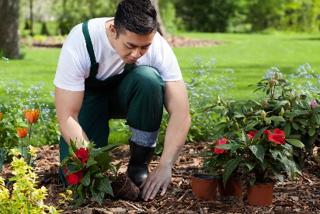



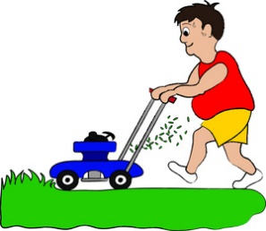

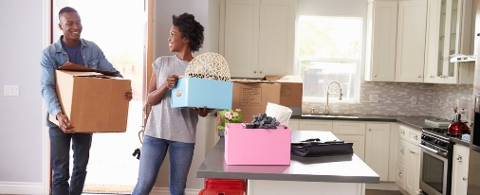

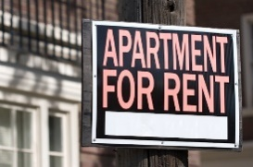



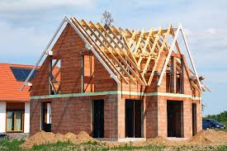

**Exercise 3.** Solve online exercises in Agenda Web about “Be going to”. Then send me the screenshots of the final result in an email.

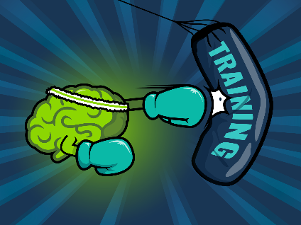

**Click here**

* <https://agendaweb.org/exercises/verbs/future/going-to-forms>
* <https://agendaweb.org/exercises/verbs/going-to>
* <https://agendaweb.org/exercises/verbs/going-to-match>
* <https://agendaweb.org/exercises/verbs/future/going-to-negative-forms>
* <https://agendaweb.org/exercises/verbs/future/going-to-interrogative-forms>