**GUÍA No. 5 – INTERDISCIPLINAR (BACHILLERATO)**

**GRADO:** __SEXTO__

|  |  |  |  |
| --- | --- | --- | --- |
| **DOCENTE** | **GRUPO** | **E-MAIL** | |
| NICOLAS MANRIQUE | 606,607,608 | [mestefannic@educacionbogota.edu.co](mailto:mestefannic@educacionbogota.edu.co) | |
| JAVIER HOYOS CAMACHO | 601,602 603 | jhoyosc@educacionbogota.edu.co | |
| LILIANA ARTEAGA | 604 | ilarteaga@educacionbogota.edu.co | |
| HARVEY LATORRE CASTRO | 605 | ralatorre@educacionbogota.edu.co | |
| **TEMA** | PRESENT CONTINUOUS | | |
| **OBJETIVOS** | | | **INDICADOR (ES) DE DESEMPEÑO:** |
| * Identificar el presente continuo y su uso en ingles * Conocer la estructura gramatical del presente continuo y como se utiliza en presente | | | * Realiza oraciones haciendo uso de la nueva estructura gramatical aprendida. |
| **AREAS - ASIGNATURAS INVOLUCRADAS:**  **INGLÉS-CLUB DE INGLES** | | | **PRODUCTO A ENTREGAR: GUÍA 5** |

**PRESENT CONTINUOUS**

El presente continuo se forma con [el verbo to be](https://madridingles.net/ingles-basico-1-el-verbo-to-be) (AM, IS, ARE) y con el gerundio. El gerundio es la forma del verbo con el sufijo **-ing.** Las reglas de ortografía son sencillas y no vamos a preocuparnos mucho de ellos, haremos simplemente una lista de varios verbos en infinitivo y a continuación en gerundio.

**C. Negative form. Fill in blanks with**

**“is/ are /not” and/or “ing”verb”**

1. **I am ______ cooking.**
2. **He _______ not eating.**
3. **She is not _____________ (laugh)**
4. **It ___ ____ _________ (rain).**
5. **They are _____painting Easter eggs.**
6. **We _____ not eating now.**
7. **You ____ _____ _________(walk).**
8. **Mary is _____ sleeping.**
9. **Kate and John ____ not watching TV.**

**10.The dog ___ _____ _______ (bark).**

**C. Negative form. Fill in blanks with**

**“is/ are /not” and/or “ing”verb”**

1. **I am ______ cooking.**
2. **He _______ not eating.**
3. **She is not _____________ (laugh)**
4. **It ___ ____ _________ (rain).**
5. **They are _____painting Easter eggs.**
6. **We _____ not eating now.**
7. **You ____ _____ _________(walk).**
8. **Mary is _____ sleeping.**
9. **Kate and John ____ not watching TV.**

**10.The dog ___ _____ _______ (bark).**

live – living, sleep – sleeping, study – studying, try – trying, speak – speaking, work – working, watch – watching, go – going, leave – leaving, make – making, do – doing, arrive – arriving, start – starting, end – ending, play – playing,

Aquí tienes **unos ejemplos.**Fíjate que siempre se usa una forma del verbo **to be** (o a veces, la forma corta) y un gerundio.

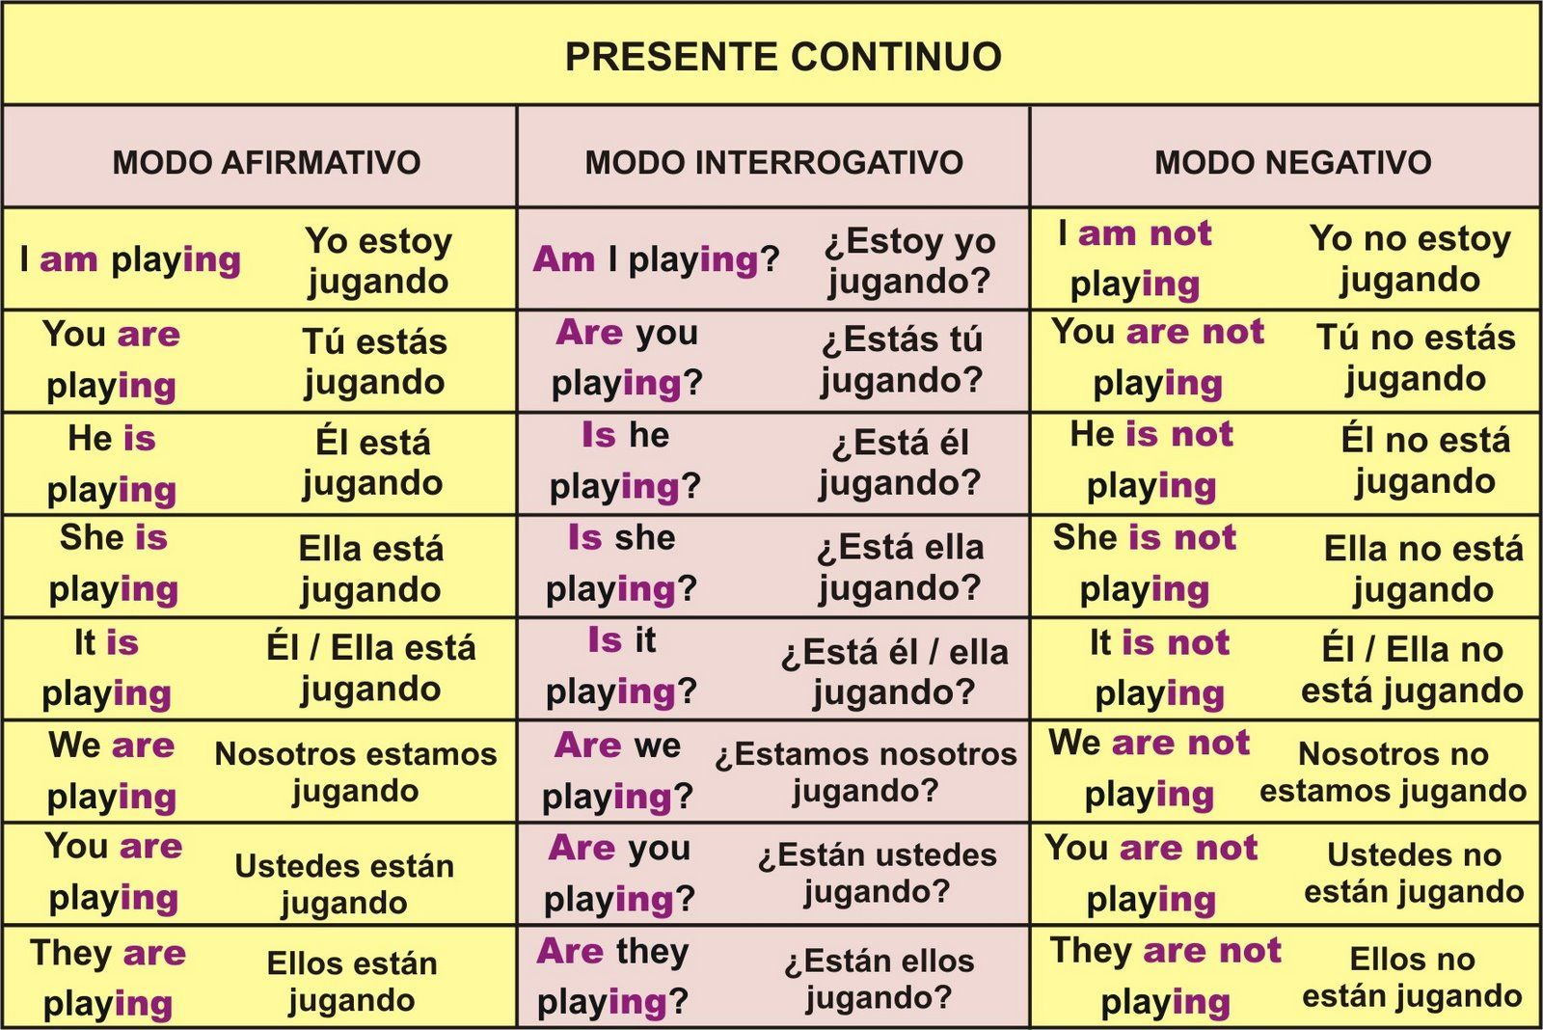

**1. Complete las oraciones haciendo uso del Present continuous, use los verbos que están entre paréntesis para completar la oración.**

1. I ___________________________________________________________ (watch) a reality show on TV.

2. My favourite team _____________________________________________(win)!

3. Someone ____________________________________________________ (swim) in the sea.

4. Two people ___________________________________________________(cook) dinner on the beach.

5. We __________________________________________________________(not watch) a soap opera.

6. I ____________________________________________________________(not do) my homework.

7. Mum _________________________________________________________(read) a magazine.

8. My brother ____________________________________________________(not listen) to the radio.

9. Dad __________________________________________________________(not cook) dinner.

10. Tara ________________________________________________________ (talk) by phone.

11. Joe _________________________________________________________ (play) on the computer.

12. Who ________________________________________________________(watch) TV?

13. Tina ________________________________________________________ (do) grammar exercises.

14. I ___________________________________________________________ (eat) a pizza.

15. We _________________________________________________________ (sit) in the classroom.

16. I ___________________________________________________________ (not write) an email.

17. Amy ________________________________________________________ (not go) to school today.

18. We _________________________________________________________ (not have) fun today.

19. My team _____________________________________________________ (not win) the match.

20. My parents __________________________________________________ (drive) to work now.

21. ___________ they ____________________________________________ (read) magazines?

Yes, they are.

22. ___________ you __________________ (learn) English? Yes I am.

23. ___________ Helen ________________ (write) a letter? No, she isn´t.

24. ___________ Sarah ________________ (play) the guitar? Yes, she is.

25. We _____________________ (not play) basketball.

**2. Complete las respuestas usando el presente continuo.**

What are you doing¬?_ What are they doing? Where is she studying?

I am ________________ English. ____ are playing football She ____ ________ at home

What is she doing? What is he playing? Where are you running ?

She is _____________ in the hospital. He ____ _________ tennis. ____________________________

**3. Responda las siguientes preguntas en INGLES usando el presente continuo con información real.**

What is your mother doing in this moment? ____________________________________________________________________________________________

What is the teacher doing in this moment?_________________________________________________________

____________________________________________________________________________________________

What are your friends doing in this moment? ____________________________________________________________________________________________

What are you doing in this moment? ____________________________________________________________________________________________

**4. Escriba oraciones diciendo lo que usted o su familia NO están haciendo en este momento (En Inglés usando el presente continuo)**

1.___________________________________________________________________________________

2___________________________________________________________________________________

3___________________________________________________________________________________

4___________________________________________________________________________________

5___________________________________________________________________________________

**5. Haga 5 preguntas y respóndalas usando el presente continuo. ( En Inglés)**

1.___________________________________________________________________________________

2___________________________________________________________________________________

3___________________________________________________________________________________

4___________________________________________________________________________________

5___________________________________________________________________________________

Si tiene dudas l@ invito a consultar el siguientes link de refuerzo: <https://www.youtube.com/watch?v=CkWCzB8dk2U>

**C. Negative form. Fill in blanks with**

**“is/ are /not” and/or “ing”verb”**

1. **I am ______ cooking.**
2. **He _______ not eating.**
3. **She is not _____________ (laugh)**
4. **It ___ ____ _________ (rain).**
5. **They are _____painting Easter eggs.**
6. **We _____ not eating now.**
7. **You ____ _____ _________(walk).**
8. **Mary is _____ sleeping.**
9. **Kate and John ____ not watching TV.**

**10.The dog ___ _____ _______ (bark).**