**GUÍA No. 5 – INTERDISCIPLINAR (BACHILLERATO)**

**GRADO:** _ONCE__

|  |  |  |
| --- | --- | --- |
| **DOCENTE** | **GRUPO** | **E-MAIL** |
| JAVIER HOYOS CAMACHO | 1101  1102  1103 | [jhoyosc@educacionbogota.edu.co](mailto:jhoyosc@educacionbogota.edu.co)  what’s app 315 3 49 10 24 |
|  |  |  |

|  |  |  |  |
| --- | --- | --- | --- |
| **TEMA** | **REVISION. STRUCTURES PAST SIMPLE VRS PRESENT PERFECT AND CONDITIONALS** | | |
| **OBEJTIVOS** | | **INDICADOR (ES) DE DESEMPEÑO:** | |
| Identificar el uso de la estructura de pasado simple vrs presente perfecto usándolas contextualmente.  Reforzar el uso de las estructuras condicionales en contextos sugeridos- | | Distingue claramente cada uno de los tiempos verbales y su uso en contexto.  Responde a preguntas hipotéticas sobre su propio contexto de usando las estructuras gramaticales correspondientes | |
| **AREAS - ASIGNATURAS INVOLUCRADAS:**  **INGLES** | | | **PRODUCTO A ENTREGAR**  **GUIA 5 DESARROLLADA** |

**ACTIVIDADES:**

|  |
| --- |
| **FECHA DE DESARROLLO:** |
| **ACTIVIDAD.** |

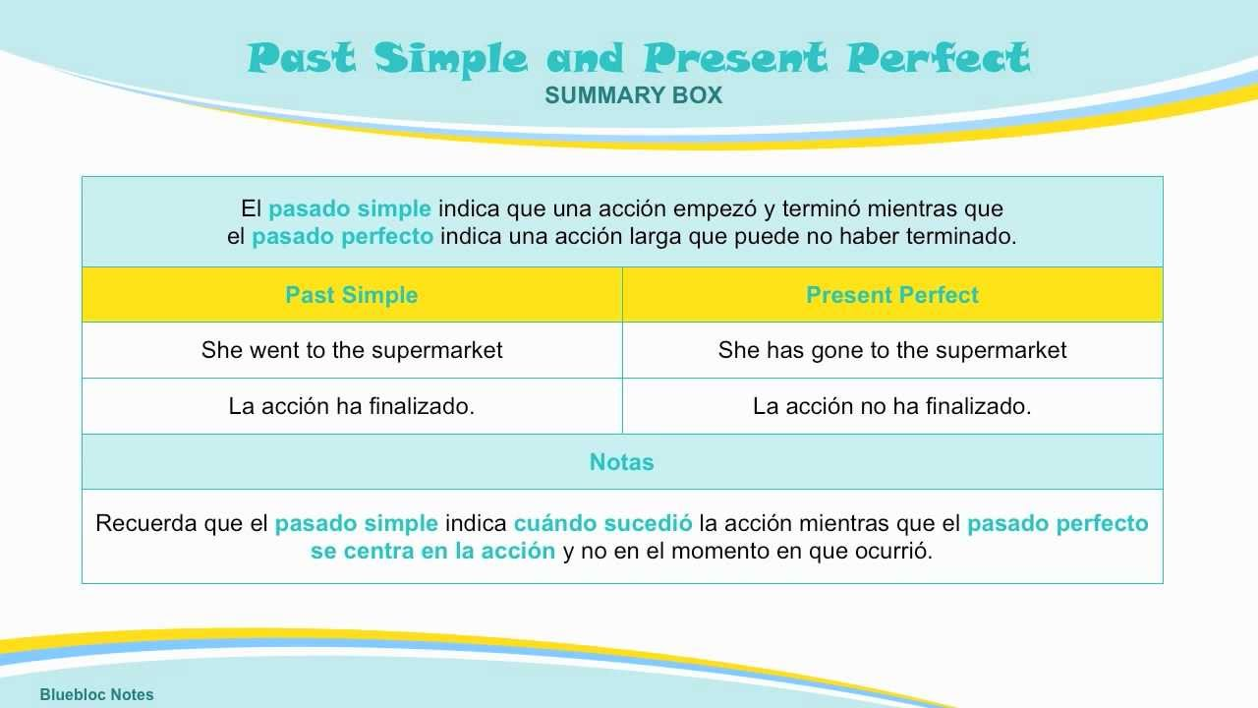

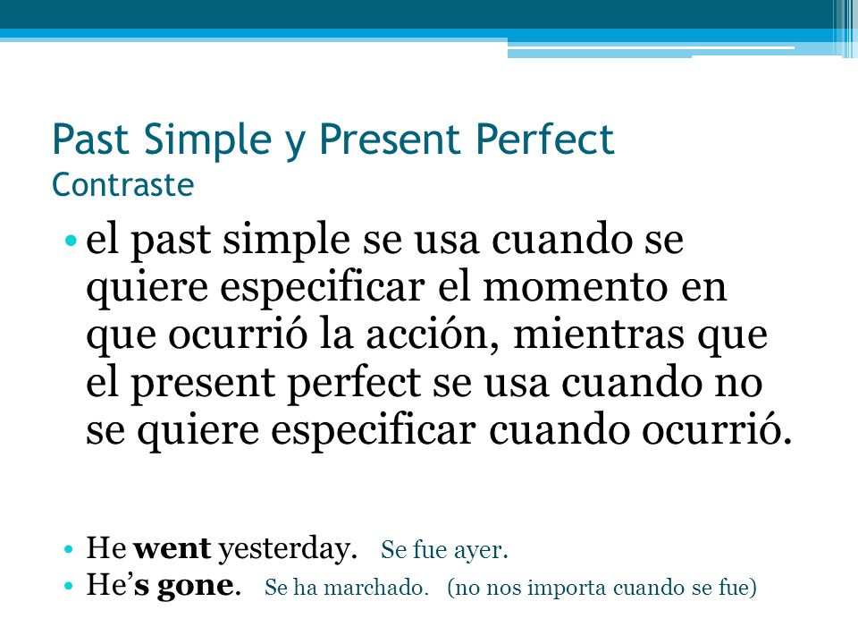

**1. Ponga los verbos en el tiempo verbal correcto. (simple past or present perfect simple).**

1. A: I (cycle / just) __________________________________ 50 km.
2. B: I (cycle) _____________________________________ 100 km last week.
3. A: I (write) _____________________________________ an essay yesterday.
4. B: I (write / already) ______________________________ two essays this term.
5. A: I (ring / just) __________________________________ my friend.
6. B: I (ring) _______________________________________  my friend 10 minutes ago.
7. A: Two days ago, I (watch) __________________________  a Madonna concert on TV.
8. B: I (see / already) __________________________________ Madonna live in concert.
9. A: I (spend)  ___________________________ my summer holiday in Australia last year.
10. B: I (be / not) ___________________________ to Australia yet.

**2. Reescriba las siguientes oraciones poniendo los verbos entre paréntesis en el tiempo verbal correcto. (simple past or present perfect simple).**

1. Mother: I want to prepare dinner. (you / wash) _____________the dishes yet?
2. Daughter: I (wash) ­­­­­­­­­­__________the dishes yesterday, but I (have / not) _________ the time yet to do it today.
3. Mother: (you / do / already) _____________________your homework?
4. Daughter: No, I (come / just) _________________ home from school.
5. Mother: You (come) ____________________home from school two hours ago!
6. Daughter: Well, but my friend Lucy (call) _________________ when I (arrive) _________and I (finish / just) ________________ the phone call.
7. Mother: (you / see / not) ___________ Lucy at school in the morning?
8. Daughter: Yes, but we (have / not) ____________ time to talk then.

1. _______________________________________________________________________________________________

2.________________________________________________________________________________________________

3. ________________________________________________________________________________________________

4. ________________________________________________________________________________________________

5. ________________________________________________________________________________________________

6._________________________________________________________________________________________________

7._________________________________________________________________________________________________

8._________________________________________________________________________________________________

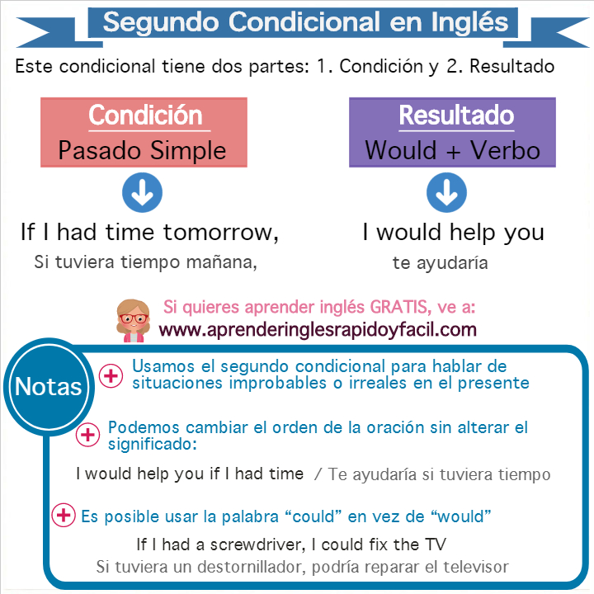

TERCER CONDICIONAL

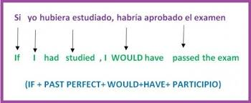

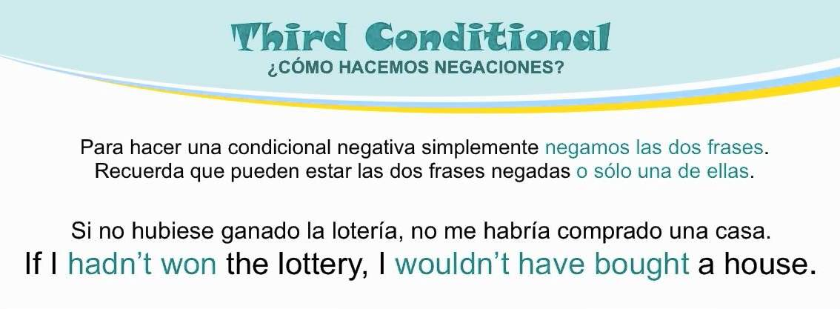

**3. Responda a las siguientes preguntas en forma larga usando la estructura condicional.**

* EJEMPLO: What would you do if you saw a robbery? If I saw a robbery I would immediately call the police

a. If you had only 24 hours to live, what would you do?_________________________________________________________________________________________________________________________________________________________________________________________________

b. If you could ask God any one question, what would it be? ____________________________________________________________________________________________________________________________________________________________________________________________________

c. If you could change one thing about yourself, what would it be? ____________________________________________________________________________________________________________________________________________________________________________________________________

d. If you could hear what someone is thinking for a day, who would you choose? ____________________________________________________________________________________________________________________________________________________________________________________________________

e. If you discovered a new island, what would you name it and why? ____________________________________________________________________________________________________________________________________________________________________________________________________

f. What would you do if you were at home at night alone and you heard a noise in your house that seemed to be a ghost? ____________________________________________________________________________________________________________________________________________________________________________________________________

g. What would you do if you found the wallet of your next door neighbor who you hated? ____________________________________________________________________________________________________________________________________________________________________________________________________

h. If you had had the opportunity to be a super hero, which super hero would you have been and why? ____________________________________________________________________________________________________________________________________________________________________________________________________

I. If you had gotten arrested for murder, whom would you have called the first ? And why?

____________________________________________________________________________________________________________________________________________________________________________________________________

j. If you had had the opportunity to travel to the past to stop the pandemia how would you have done it?

________________________________________________________________________________________________________________________________________________________________________________________________________________________________________________

Si tiene dudas l@ invito a consultar los siguientes links de refuerzo, <https://www.youtube.com/watch?v=_eIJgkeNfJk>

<https://www.youtube.com/watch?v=jjbHhhAj0vU> <https://www.youtube.com/watch?v=UO2op3sVQ5E>