INGLÉS – 11° Once

Recuperación

OBJETIVO: Distinguir entre la voz active y pasiva en las oraciones.

INDICADOR: Explicar procesos simples usando la voz pasiva.


PASSIVE VOICE
The passive voice is used to show interest in the person or object that experiences an action rather than the person or object that performs the action. In other words, the most important thing or person becomes the subject of the sentence.


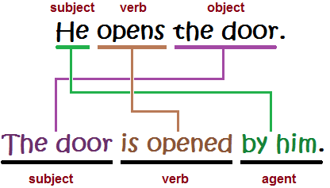

Examples:



- I wash my car

- My car is washed by me


- The gardener doesn’t water the flowers every day

- The flowers aren’t watered by the gardener every day.



- Does the painter paint beautiful pictures?

- Are beatiful pictures painted by the painter?

Past Participle

- English verbs can be separated into two categories – regular verbs and irregular verbs. Regular verbs follow a simple pattern in which both the past simple and the past participle form of the verb are created by adding -ed. For example,


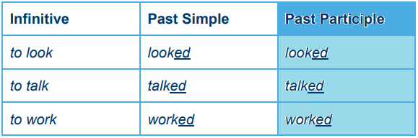

- So, creating past participle from regular verbs is quite easy. Unfortunately, there are also irregular verbs in English which don’t follow a fixed pattern. In this case you simply need to learn them. The best way to do this is to learn them gradually as part of a structured course. This is how students at Wall Street English learn regular and irregular verbs, and it’s more practical and fun than trying to memorize a long list.

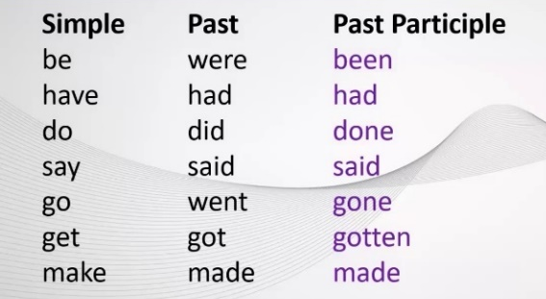

OBJECT PRONOUNS

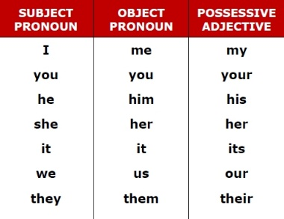

What are object pronouns?
An object pronoun, also called objective pronoun, functions as the object of a verb or preposition, as distinguished from a subject or subjective pronoun, which is the subject of a verb.
Examples:
- She told them the truth. (them is the object of the verb told)
- She's my friend. I really enjoy being with her.
- I like this film. I saw it last week.
- I like you but you don't like me.
- Do you really hate her?
- She loves sitting next to him.
- She always writes e-mails to us.
- He's talking to her about it.



Watch the video to reinforce the “Passive Voice” grammar.

Click here

https://www.youtube.com/watch?v=W1_IRU6zx9g

https://www.youtube.com/watch?v=SRcE7UPIDLo

Nombre del Estudiante |  |  |  | Curso
Sede |  |  |  | Jornada
Correo electrónico:
 | Nombre Director de Curso:
HOJAS DE TRABAJO
GUÍA # 8

Exercise 1. Fill the gaps with the correct Object pronouns. Then match the sentences with the pictures.

  - I am hungry, the hamburger is for ________
  - Where do you live? We want to visit ________
  - We are going for a walk. Come with ________

  - I like your shoes, Where did you get ________
  - How much is that dress. I like _______ very much.
  - Where is Jimmy? We are wainting for _______
  - Are your parents at home? I want to talk to _______

  - I can’t solve this exercise. Could you help _______
  - Pamela likes flowers. This bouquet is for ________
  - Andrés writes very well. That poem was written by _______



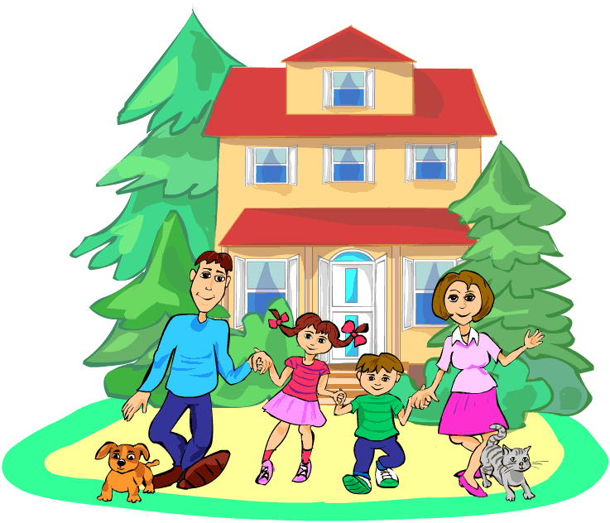






Exercise 2. Tick the correct form (active or passive voice).

No. | Sentences | Active | Passive
a. | The wall is painted by my Dad.
b. | The doctor talks to him.
c. | My parents give me a present every Christmas.
d. | English is spoken here.
e. | Olive oil is made from olives.
f. | I do my homework in the afternnoons.
g. | Reporters write news reports.
h. | The questions are answered by the teacher.
i. | News reports are written by reporters.
j. | A cake is made.
k. | I make a cake.

Exercise 3. Write the following sentences in Passive voice. Affirmative form.
  - Sam uses my towel. ______________________________________________________
  - I serve lunch at half past one. _______________________________________________
  - Nurses vaccinate people __________________________________________________
  - We clean the house on Sundays. ____________________________________________
  - They publish a magazine each month. ________________________________________
  - An old woman feeds the pigeons. ____________________________________________
  - You help my sister. _______________________________________________________
  - Juan drives the bus. ______________________________________________________
  - I water the plants on weekends. _____________________________________________
  - The chef cooks food every day. _____________________________________________

Exercise 4. Write the following sentences in Passive voice. Negative form.
  - Sam doesn’t use my towel. _____________________________________________________
  - I don’t serve lunch at half past one. _______________________________________________
  - Nurses don’t vaccinate people __________________________________________________
  - We don’t clean the house on Sundays. ____________________________________________
  - They don’t publish a magazine each month. ________________________________________
  - An old woman doesn’t feed the pigeons. ___________________________________________
  - You don’t help my sister. _______________________________________________________
  - Juan doesn’t drive the bus. ______________________________________________________
  - I don’t water the plants on weekends. _____________________________________________
  - The chef doesn’t cook food every day. _____________________________________________

Exercise 5. Write the following sentences in Passive voice. Interrogative form.
- Does Sam use my towel? ______________________________________________________
- Do I serve lunch at half past one? ________________________________________________
- Do nurses vaccinate people? ___________________________________________________
- Do we clean the house on Sundays? _____________________________________________
- Do they publish a magazine each month? _________________________________________
- Does an old woman feed the pigeons? ___________________________________________
- Do you help my sister? ________________________________________________________
- Does Juan drive the bus? ______________________________________________________
- Do I water the plants on weekends? _____________________________________________
- Does the chef cook food every day? _____________________________________________



RESOURCES

https://agendaweb.org/exercises/grammar/pronouns/object-4
https://agendaweb.org/exercises/verbs/passive-voice/active-passive-1
https://agendaweb.org/exercises/verbs/passive-voice/active-passive-2
https://agendaweb.org/exercises/verbs/passive-voice/passive-1
https://agendaweb.org/exercises/verbs/passive-1

