INGLÉS / HUMANIDADES GRADO 8°
Recuperación segundo periodo
Liliana Arteaga

OBJETIVO: Usar el verbo “to be” en pasado simple.

INDICADOR: Hablo de situaciones o hechos que sucedieron en el pasado usando el verbo “to be”.

Verb “to be” in past


Quizás el verbo más importante en inglés sea este, el verbo to be. No solo nos sirve para expresar nuestro estado de ánimo, sino que es uno de los verbos auxiliares del inglés. Es clave, también, que conozcas a la perfección el verbo to be en pasado.

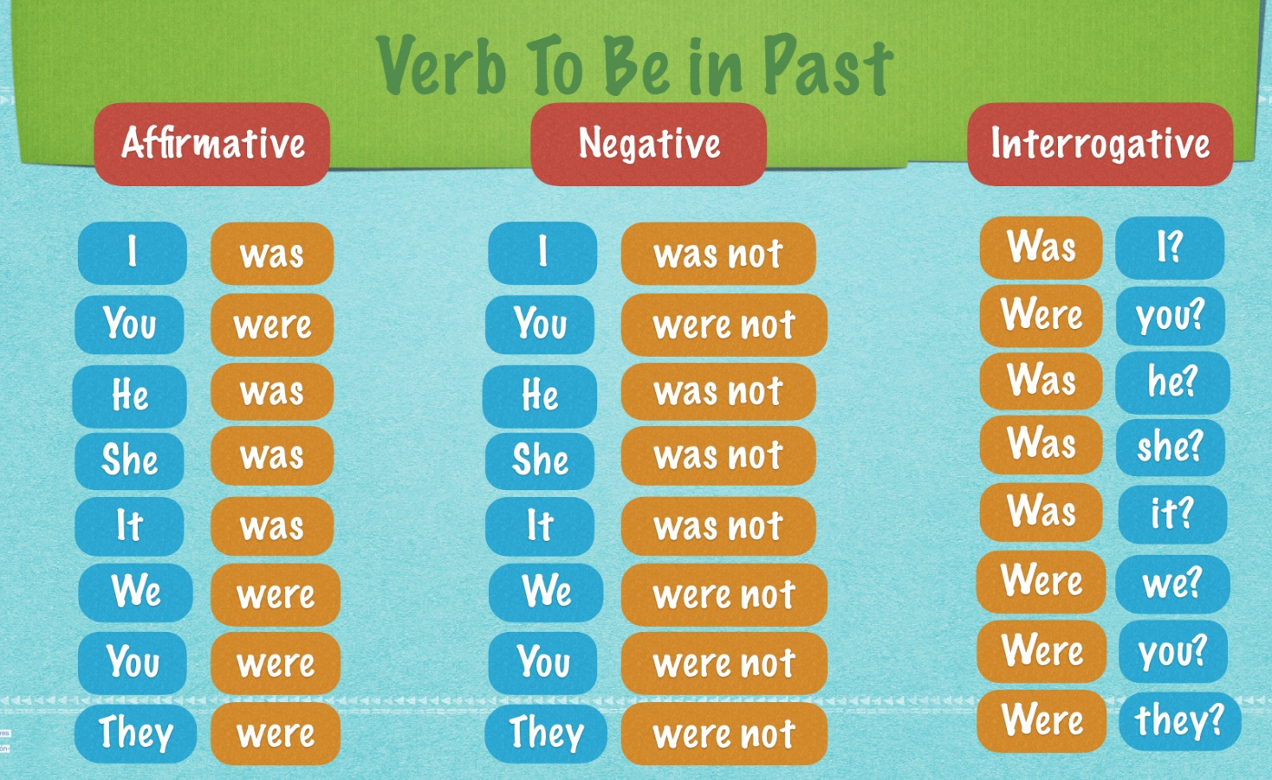

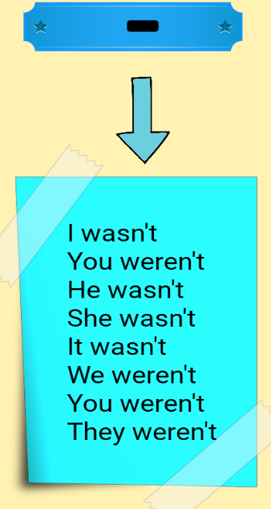
NEGATIVE CONTRACTIONS

AFFIRMATIVE FORM

SUBJECT | VERB TO BE
I | WAS | IN MY HOUSE.
YOU | WERE | TIRED YESTERDAY.
HE | WAS | MY BOSS LAST YEAR.
SHE | WAS | WITH HER MOM LAST WEEKEND.
IT | WAS | VERY BEAUTIFUL IN THE PAST.
WE | WERE | AT THE MALL LAST NIGHT.
YOU | WERE | IN YOUR OFFICE THIS MORNING.
THEY | WERE | IN USA LAST MONTH.



NEGATIVE FORM

SUBJECT | VERB TO BE | NOT
I | WAS | NOT | IN MY HOUSE.
YOU | WERE | NOT | TIRED YESTERDAY.
HE | WAS | NOT | MY BOSS LAST YEAR.
SHE | WAS | NOT | WITH HER MOM LAST WEEKEND.
IT | WAS | NOT | VERY BEAUTIFUL IN THE PAST.
WE | WERE | NOT | AT THE MALL LAST NIGHT.
YOU | WERE | NOT | IN YOUR OFFICE THIS MORNING.
THEY | WERE | NOT | IN USA LAST MONTH.


INTERROGATIVE FORM

VERB TO BE | SUBJECT
WAS | I | IN MY HOUSE?
WERE | YOU | TIRED YESTERDAY?
WAS | HE | MY BOSS LAST YEAR?
WAS | SHE | WITH HER MOM LAST WEEKEND?
WAS | IT | VERY BEAUTIFUL IN THE PAST?
WERE | WE | AT THE MALL LAST NIGHT?
WERE | YOU | IN YOUR OFFICE THIS MORNING?
WERE | THEY | IN USA LAST MONTH?




Watch the video to reinforce grammar rules of “VERB TO BE IN PAST”

Click here

https://www.youtube.com/watch?v=Y0Dsx7tjTqM

TIME EXPRESSIONS FOR THE PAST TENSE

YESTERDAY = Ayer | LAST = Pasad@ | AGO = hace
Yesterday morning | Last night | 10 minutes ago | In 1990
Yesterday afternoon | Last week | Two hours ago | In March
Yesterday evening | Last weekend | Three days ago | On Monday
Yesterday night | Last month | Two weeks ago | At 8:00
The day before yesterday | Last year | Six months ago | Recently
 | Last vacation | A year ago | In the past
 | Last decade | A Little while ago | At Christmas
 | Last century | A long time ago | In summer
 |  |  | On vacation
 |  |  | This morning
 |  |  | This afternoon
 |  |  | The other day
 |  |  | When I was born
 |  |  | When I was a child

Watch the video to reinforce “TIME EXPRESSIONS FOR THE PAST TENSE”

Click here

https://www.youtube.com/watch?v=sSl1CVgmUmk

HOJAS DE TRABAJO

Exercise 1. Rewrite the sentences using was or were. See the example.

- I am happy to see you.
I was happy to see you_____
- This is my favourite book.
______________________________________
- You are my best friend.
_______________________________________
- Mary is at school.
_______________________________________
- The dogs are under the table.
_______________________________________
- It is a very interesting film.
_______________________________________
- We are good sportsmen.
_______________________________________
- My mobile is broken.
_______________________________________
- They are at the shopping centre.
_______________________________________
- I am always at home on Weekends.
_______________________________________

Exercise 2.Translate the previous sentences in past. See the example.

No. | TRANSLATION
1. | Yo estaba feliz de verte.
2.
3.
4.
5.
6.
7.
8.
9.
10.


Exercise 3. Circle the correct conjugation of the verb to be. Then match the sentences with the corresponding picture. See the examples.


- They was / were in the Natural History Museum Yesterday.
- Jhon was / were in Paris last Summer.
- Andrew was / were the best student in our class last year.
- I was / were responsible for my brothers in the past.

- The article in the local newspaper was / were very interesting.
- Last winter was / were the coldest winter in our region.
- Pamela was / were an excellent dancer when she was young.
- Those houses was / were built two hundred years ago.

- Tom was / were worried because he left the keys at home.
- Your e-mail was / were very difficult to remember.
- You was / were sick last weekend.
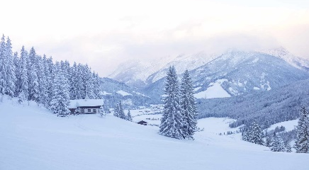
a
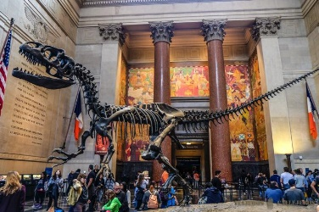
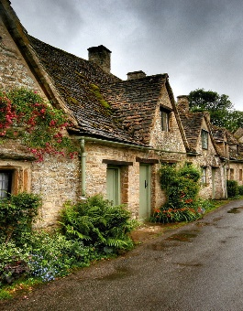








Exercise 4. Write the following sentences in negative form was not or were not. See the example.

- I was at home last weekend.
I was not at home last weekend.
- He was a good student.
______He not was a good student_________________________________
- We were at the movies last night.
_______________________________________
- I was at the station yesterday.
_______________________________________
- The students were in the classroom ten minutes ago.
_______________________________________
- My father was a policeman five years ago.
_______________________________________
- Tom and Mike were friends.
_______________________________________
- The houses were old.
_______________________________________
- The book was in the bag.
_______________________________________
- The doctors were in the hospital this morning.
_______________________________________

Exercise 5.Translate the previous sentences in past. See the example.

No. | TRANSLATION
1. | Yo no estaba en casa el fin de semana pasado.
2.
3.
4.
5.
6.
7.
8.
9.
10.

Exercise 6. Answer the questions according to the following text using verb to be in past.

- Read the text.

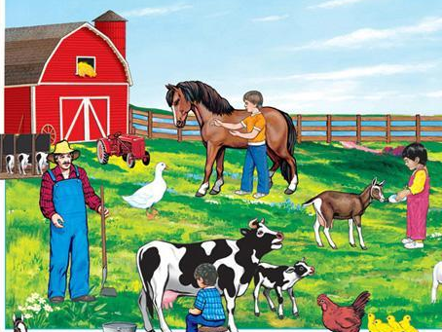
Mike: That’s a nice picture.
Grandma: Yes, it was our farm. It was really beautiful and big. The animals were very beautiful.
Sally: This was my favorite pet.
Mike: Look at Grandpa. He was very thin and his hair was black! But Grandma, you weren’t in this picture.

Grandma: No, I was at Flower Festival. Life in the country was peaceful. Life in the city is very noisy and dangerous.
Mike: Oh, Grandma, look at this picture, you are here! You were young and pretty. Your hair was blonde. Your dress was red and beautiful.
Grandma: Yes, those times were so nice and wonderful.

- How was the farm?
_The farm was really beautiful and big.__
- Were the animals ugly?
__NO________________________________________________
- Was Grandpa very thin?
___________________________________________________
- Why wasn’t Grandma in the picture?
_______________________because ____________________________
- Was life in the country very noisy and dangerous?
___________________________________________________
- Was Grandma young and pretty?
___________________________________________________

OBJETIVO: To know the structure of Simple Past tense in English.

INDICADOR: The students talk about past events using Simple Past tense.

Simple Past tense

The simple past tense shows that you are talking about something that has already happened. The simple past tense emphasizes that the action is finished.

Regular Verbs

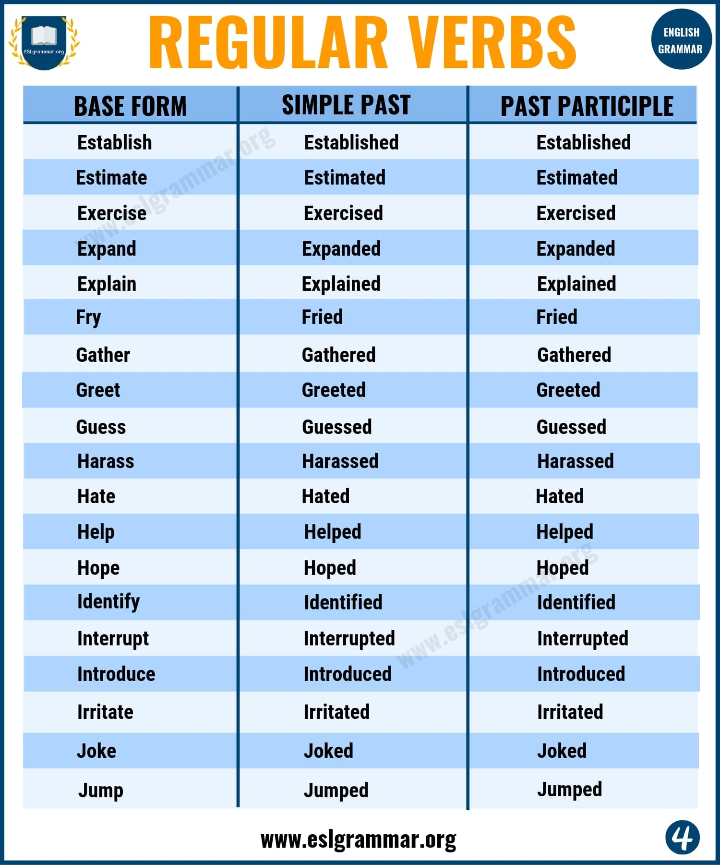
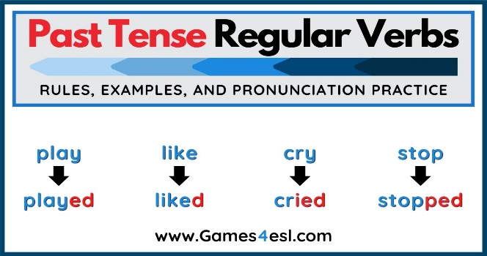

Irregular Verbs

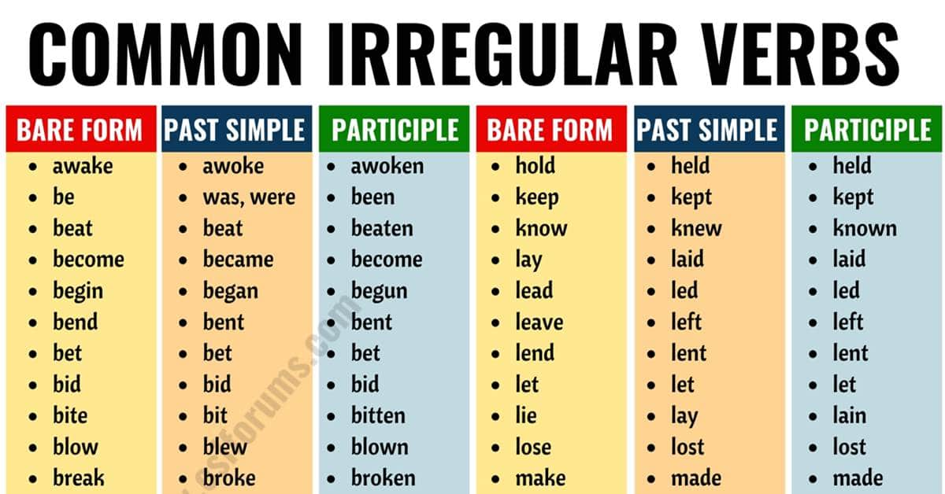

AFFIRMATIVE FORM

SUBJECT | VERB IN PAST
I | WROTE | A NOTE FOR YOU YESTERDAY.
YOU | ENJOYED | YOU VACATIONS LAST MONTH
HE | BOUGHT | A NEW CAR THREE DAYS AGO.
SHE | WORKED | IN THIS FACTORY.
IT | RAINED | ALL NIGHT.
WE | STUDIED | AT THE SAME SCHOOL WHEN WE WERE KIDS.
YOU | SENT | A MESSAGE ON INSTAGRAM AT 10:00 A.M.
THEY | WENT | TO CARTAGENA LAST YEAR.

NEGATIVE FORM
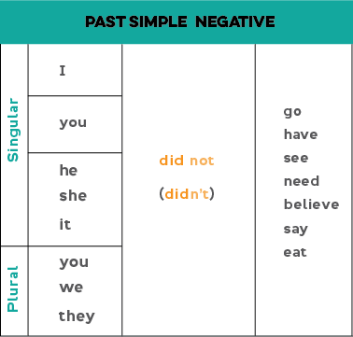

SUBJECT | DIDN’T | VERB
I | DIDN’T | WRITE | A NOTE FOR YOU YESTERDAY.
YOU | DIDN’T | ENJOY | YOU VACATIONS LAST MONTH
HE | DIDN’T | BUY | A NEW CAR THREE DAYS AGO.
SHE | DIDN’T | WORK | IN THIS FACTORY.
IT | DIDN’T | RAIN | ALL NIGHT.
WE | DIDN’T | STUDY | AT THE SAME SCHOOL WHEN WE WERE KIDS.
YOU | DIDN’T | SEND | A MESSAGE ON INSTAGRAM AT 10:00 A.M.
THEY | DIDN’T | GO | TO CARTAGENA LAST YEAR.

INTERROGATIVE FORM
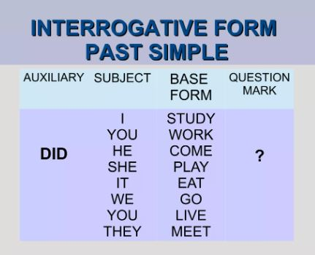



Watch the video to reinforce grammar rules of REGULAR AND IRREGULAR VERBS and SIMPLE PAST TENSE.

Click here

https://www.youtube.com/watch?v=8kUyDtk0Yjw
https://www.youtube.com/watch?v=wLuNOWXw96c

Exercise 1. Fill in the blanks using the verbs in brackets in order to form afirmative sentences in Simple Past tense.

- Christopher Columbus __________________ America in 1493. (discover)
- He __________________ to the airport at 8:00 a.m. (arrive)
- He __________________ his parents last Summer. (visit)
- I ____________________ an English book last year. (have)
- Kevin ________________ his leg while he was playing football. (hurt)
- She __________________at the Olympics two years ago. (swim)
- Steve ________________ his bicycle to school yesterday. (ride)
- The child _____________ some milk last night. (drink)
- My Dad ______________ his apartment this morning. (clean)
- We __________________ in the park on Sunday. (walk)

Exercise 2. Translate the previous sentences in Simple Past tense.

No. | TRANSLATION
1.
2.
3.
4.
5.
6.
7.
8.
9.
10.

Exercise 3. Fill in the blanks using the verbs in brackets in order to form negative sentences in Simple Past tense.

- Christopher Columbus _didn’t discover_ America in 1493. (discover)
- He __________________ to the airport at 8:00 a.m. (arrive)
- He __________________ his parents last Summer. (visit)
- I ____________________ an English book last year. (have)
- Kevin ________________ his leg while he was playing football. (hurt)
- She __________________at the Olympics two years ago. (swim)
- Steve ________________ his bicycle to school yesterday. (ride)
- The child _____________ some milk last night. (drink)
- My Dad ______________ his apartment this morning. (clean)
- We __________________ in the park on Sunday. (walk)

Exercise 4. Write the previous sentences in interrogative form.

No. | TRANSLATION
1.
2.
3.
4.
5.
6.
7.
8.
9.
10.



