PROCESO DE NIVELACIÓN Y RECUPERACIÓN 1P 2026
GRADO NOVENO | CURSO:
ASIGNATURA: | INGLÉS
NOMBRE DEL DOCENTE: | HARVEY LATORRE CASTRO

PLANEACIÓN GENERAL DE LA NIVELACIÓN
PROPÓSITO GENERAL
Desarrollar la capacidad de lectura comprensiva en diversos textos y la producción y escritura de ideas en Inglés.
Debe ser capaz de realizar descripciones y comparaciones mediante el vocabulario y las estructuras gramaticales pertinentes.
PROPÓSITOS ESPECÍFICOS
APRENDER A SER | Sea capaz de desarrollar sus actividades escolares guardando siempre actitudes de respeto.
APRENDER A CONOCER | Conozca estructuras gramaticales y vocabulario concernientes a los temas vistos.
APRENDER A HACER | Lea comprensivamente y haga descripciones y comparaciones.

EVALUACIÓN
ACTIVIDAD | CRITERIOS DE EVALUACIÓN | METODOLOGÍA | RECURSOS
Actividad 1 | Identificación de los temas vistos durante el PRIMER PERIODO. | Consignar en el cuaderno de la asignatura el contenido de la guía desarrollando los talleres respectivos. | Cuaderno de la asignatura.  Videos de los temas vistos.  Fotocopias.
Actividad 2 | Realización de los talleres y ejercicios propuestos. | Presentarse a las sesiones de trabajo en el colegio, según cronograma institucional.  Trabajo en casa para complementar los procesos. | Gráficas.  Televisor.
Actividad 3 | Presentación de prueba de suficiencia | Evaluación escrita de algunos contenidos.  Evaluación oral de algunos temas. | Fotocopias

ACTIVIDADES PROPUESTAS

Debe presentar todos los apuntes y actividades desarrolladas en el periodo y copiar y desarrollar en su cuaderno, la presente guía con sus respectivos talleres y ejercicios.

SIMPLE PRESENT

El siguiente divertido video te será de gran ayuda:

https://www.youtube.com/watch?v=sfjUz-Oyq5E

El "simple present" se utiliza:
- Para expresar hábitos y rutinas, hechos generales, acciones repetidas o situaciones, emociones y deseos permanentes:
I smoke (hábito); I work in London (permanencia); London is a large city (hecho general)
- Para dar instrucciones o indicaciones:
You walk for two hundred meters, then you turn left.
- Para hablar de eventos programados, presentes o futuros:
Your exam starts at 09.00.

¡Cuidado! El "simple present" no se utiliza para hablar de lo que está ocurriendo en este momento.

Ejemplos
- Hábitos y rutinas
He drinks tea at breakfast.
She only eats fish.
They watch television regularly.
- Eventos y acciones repetidos
We catch the bus every morning.
It rains every afternoon in the hot season.
They drive to Monaco every summer.
- Hechos generales
Water freezes at zero degrees.
The Earth revolves around the Sun.
Her mother is Peruvian.
I am student
- Instrucciones o indicaciones
Open the packet and pour the contents into hot water.
You take the No.6 bus to Watney and then the No.10 to Bedford.
- Eventos programados
His mother arrives tomorrow.
Our holiday starts on March 27th

Formación del "simple present": to think
Afirmativa | Interrogativa | Negativa
I think | Do I think? | I do not think
You think | Do you think? | You do not think
He thinks | Does he think? | He does not think
She thinks | Does she think? | She does not think
It thinks | Does it think? | It does not think
We think | Do we think? | We do not think.
They think | Do they think? | They do not think.

Notas sobre la tercera persona del singular del "simple present"
- En la tercera persona del singular, el verbo siempre termina en -s:
he wants, she needs, he gives, she thinks.
- Para las formas negativa e interrogativa, se emplea DOES (= tercera persona del auxiliar 'DO') + el infinitivo del verbo.
He wants ice cream. Does he want strawberry? He does not want vanilla.
- Verbos que terminan en -y : en la tercera persona del singular, se cambia la -y por -ies:
fly --> flies, cry --> cries
Excepción: cuando una vocal precede a la -y:
play --> plays, pray --> prays
- Añadimos -es a los verbos que terminan en:-ss, -x, -sh, -ch:
he passes, she catches, he fixes, it pushes

- He goes to school every morning.
- She understands English.
- It mixes the sand and the water.
- He tries very hard.
- She enjoys playing the piano.

We use the simple present tense when an action happens regularly (or unceasingly, which is why it's sometimes called present indefinite). Depending on the person (third PERSON), the simple present tense is formed by using the root form or by adding -s or -es to the end.

TO BE VERB AND PRESENT TENSE

PERSONAL PRONOUNS
I
YOU
HE
SHE
IT
WE
YOU
THEY

PERSONAL PRONOUNS and ToBe verb: am,is,are
I am
YOU are
HE is
SHE is
IT is
WE are
YOU are
THEY are

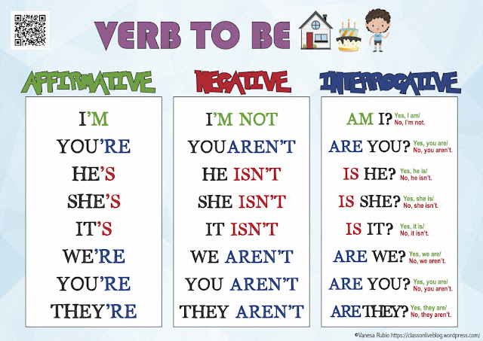

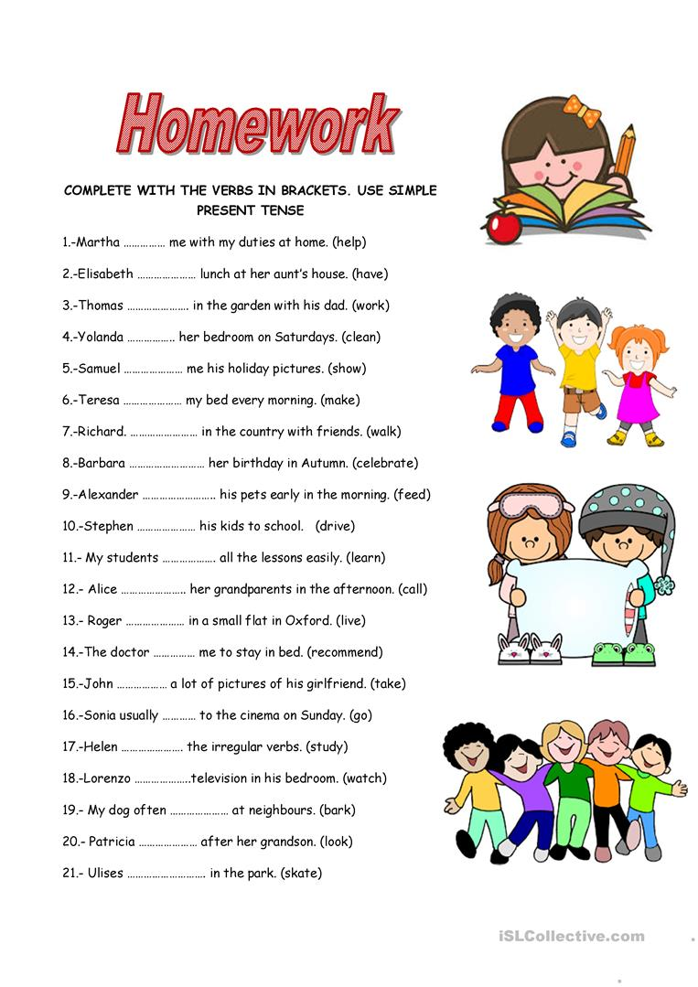
PRESENT CONTINUOS

📘 ¿Qué es el presente continuo en inglés?
El presente continuo (Present Continuous) se usa para hablar de acciones que están pasando ahora mismo, en este momento.

✅ ¿Cómo se forma?
Se forma con:
Sujeto + verbo “to be” (am / is / are) + verbo con -ing
👉 Ejemplos:
- I am eating → Yo estoy comiendo
- She is reading → Ella está leyendo
- They are playing → Ellos están jugando

👀 ¿Cuándo se usa?
Usamos el presente continuo para:
- Acciones que ocurren ahora mismo:
  - We are watching a movie.
(Estamos viendo una película ahora.)
- Acciones temporales:
  - I am living with my uncle this month.
(Estoy viviendo con mi tío este mes.)
- Situaciones que cambian:
  - The weather is getting colder.
(El clima se está poniendo más frío.)

⚠️ Algunos cambios ortográficos con -ing:
- run → running (dobla la consonante)
- make → making (quita la “e” final)
- swim → swimming (dobla la “m”)

🎯 Ejercicio rápido:
Cambia estas frases al presente continuo:
- (She / eat) → __________
- (We / study) → __________
- (I / play) → __________
A Haunted House Story
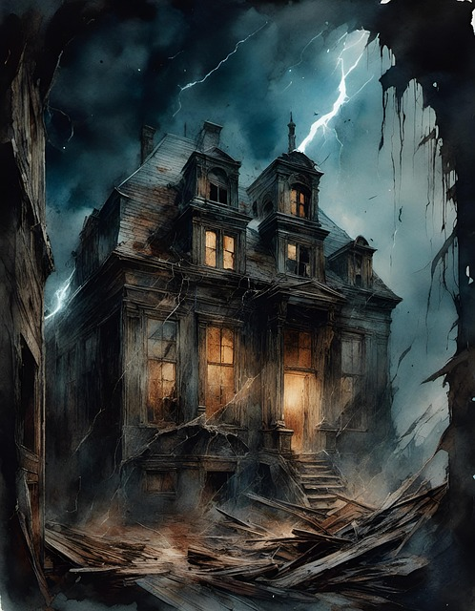

We are visiting a haunted house. It is very old and very dark. Right now, we are walking into the living room. The windows are making strange noises, and the wind is blowing the curtains. A chair is moving by itself. We are looking around, but we don’t see anyone.
Now, we are going to the kitchen. The lights are turning on and off. The fridge is opening slowly. We are hearing something strange — maybe someone is whispering. The plates are shaking, and the water is running in the sink. We are feeling scared.
Next, we are walking up the stairs to the bedroom. The door is opening. A bed is shaking, and the closet is opening. We are hearing footsteps. We are not alone. A shadow is moving near the window. We are hiding behind the bed.
Then, we are going to the bathroom. The mirror is breaking, and the lights are blinking. The water is dripping, and something is writing on the mirror. We are not touching it. We are screaming. Something is in the bathroom with us.
We are running to the attic. Boxes are falling. A doll is staring at us. The floor is making strange sounds. We are trying to leave. We are opening the front door, but it is closing again. We are trapped!
Now, we are staying quiet in the hallway. We are listening carefully. The house is alive. We are very scared, and we are trying to escape.

Answer with full present tense sentences the following questions about the Haunted House Text.

- Where are the people at the beginning of the story?
- What is moving by itself in the living room?
- What is happening to the lights in the kitchen?
- What is running in the kitchen sink?
- Where do they hear footsteps?
- What is the bed doing in the bedroom?
- What is breaking in the bathroom?
- What is writing on the mirror?
- What is staring at them in the attic?
- Why can’t they leave the house?

PAST TENSE



¿Qué es el pasado simple en inglés?
Past simple, simple past o pasado simple en español, es la forma más común de expresar acciones que comenzaron y concluyeron en un tiempo anterior.
En inglés, el pasado simple o past simple es uno de los tiempos verbales esenciales y que se utiliza con mucha frecuencia. Al usar el pasado simple o past simple nos referimos a acciones que se llevaron a cabo en un tiempo anterior y finalizaron, bien sean generalidades o acciones cotidianas o que también se repiten.
La fórmula básica de las afirmaciones en pasado simple es: Sujeto + verbo en pasado + complemento. Es la forma más sencilla, ya que lo único que debe hacerse es conjugar el verbo en pasado. ... Ej: “I bought a car last summer” (Yo compré un auto el verano pasado). “She went to the cinema yesterday” (Ella fue al cine ayer).

Tanto en inglés como en español, el tema de los verbos es extenso y, en ocasiones, no tan fácil. Con algunos verbos se aplican reglas sencillas y con otros solo queda aplicar la memoria.

Verbos regulares
En el caso de los verbos regulares, cuando se forma el pasado simple o simple past, basta con agregar la terminación -ED. Esto es una regla que se aplica en la mayoría de los casos, aunque tiene algunas excepciones.
Te mostramos algunos verbos regulares formando el pasado simple o simple past:

ESPAÑOL | VERB | SIMPLE PAST
trabajar | work | worked
saltar | jump | jumped
hablar | talk | talked
caminar | walk | walked
lavar | wash | washed

Verbos con cambios ortográficos y excepciones
A continuación te presentamos algunas reglas de ortografía a tener en cuenta cuando aplicamos el simple past:
- Si el verbo termina en e, solo se agrega -d. Ejemplo: love (amar) – loved.
- Si el verbo termina en consonante más la y, esta se sustituye por i para luego agregar la terminación –ed. Ejemplo: cry (llorar) – cried. En cambio, si el verbo termina en vocal más la y, solo se agrega la terminación –ed. Ejemplo: enjoy (disfrutar) – enjoyed.
- Si el verbo es monosílabo y termina en una vocal más una consonante, esta última se duplica para luego agregar la terminación -ed. Ejemplo: hug (abrazar) – hugged. Como toda regla, hay excepciones. Para aquellos verbos que terminan en c, x, w o y no aplica esta regla. Ejemplo: show (mostrar) – showed, play (jugar) – played. Tampoco para aquellos verbos monosílabos que terminan en dos vocales más una consonante. Ejemplo: cook (cocinar) – cooked.

Verbos irregulares
En cuanto a los verbos irregulares, estos no siguen reglas definidas para formar el pasado simple o simple past por lo que hay que estudiarlos en forma individual y memorizarlos.
SPANISH VERB PAST TENSE
Empezar. Begin Began
Ser-Estar Be Was-Were
Hablar Speak Spoke

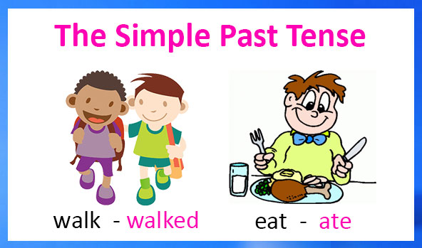

CÓMO ENTENDER EL PAST SIMPLE (NEGATIVE AND INTERROGATIVE)

Para formar oraciones negativas e interrogativas en pasado simple, se utiliza el pasado del verbo auxiliar do, es decir, did, acompañado del verbo correspondiente en infinitivo. No importa si el verbo es regular o irregular, puesto que todos los verbos utilizan el auxiliar did y el infinitivo (verbo en presente), nunca el pasado del verbo.

LO QUE DEBES SABER DEL PAST SIMPLE NEGATIVE

Si hay algo sencillo en el inglés es la formación de las frases negativas. Solo tienes que añadir el didn’t después del sujeto, dejar el verbo principal en su infinitivo y ¡listo!
Anne didn’t go to the office last week. (Anne no fue a la oficina la semana pasada)
Peter didn’t play football yesterday. (Peter no jugó al fútbol ayer).
No importa si el verbo es regular o irregular, pues siempre se mantendrá con su forma del infinitivo en las oraciones negativas, pero sin el to.
Para el verbo have, también se emplea el auxiliar did para formar el past simple negative y past simple interrogative.

Ejemplo:
I didn’t have any pets when I was a child. (No tuve ninguna mascota cuando era niño).

LO QUE DEBES SABER DEL PAST SIMPLE INTERROGATIVE

Veamos ahora cómo se forma la frase interrogativa del pasado simple:
Did + Sujeto + infinitivo del verbo sin to + objeto
Ejemplos:

Did you buy the book? (¿Compraste el libro?).
Did you study for the exam? (¿Estudiaste para el examen?).
Tal como ocurre en la forma del pasado simple negativo, la interrogación de este tiempo verbal se hace de una forma tan sencilla como puedes ver en el anterior ejemplo, sin conjugar ningún verbo. Tan sólo con el verbo auxiliar did (el pasado simple de do).

Aquí están los videos de apoyo:
https://www.youtube.com/watch?v=3jWLMZrTzyQ
https://www.youtube.com/watch?v=pPW3cgcaHCQ
https://www.youtube.com/watch?v=ZWZ6cNq6bEY&t=115s
https://www.youtube.com/watch?v=ool2Whw--7Y

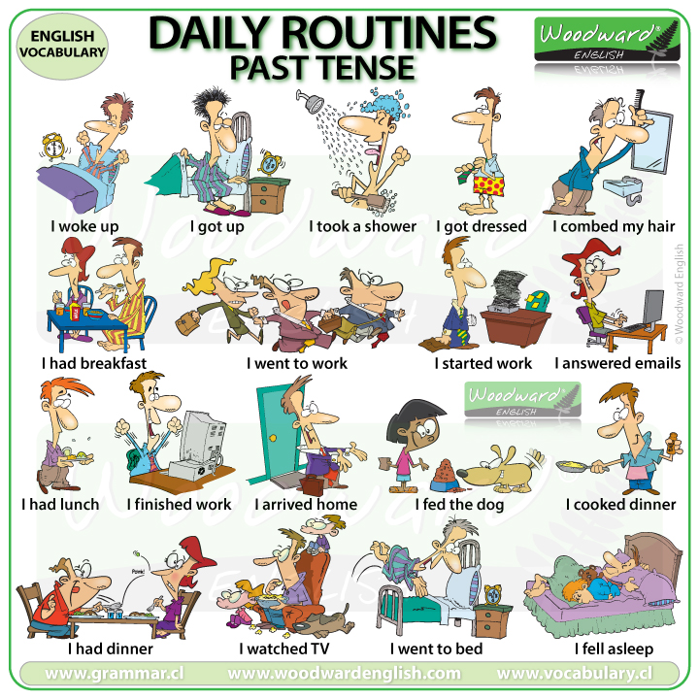

1. Complete los espacios con laforma adecuada del verbo que está en parentesis

2. Completa los espacios en blanco para formar el past simple negative de las siguientes oraciones:
- What a shame! I (to bring) _____ ______ the wallet.

- I’m starving! I (to eat) _____ ______ anything last night.

- You (to do) _____ ______ the homework. Why?

- She (to want) _____ ______ to participate in the race.

- I (to have) _____ ______ any money when I was a teenager.

3. Transforma las siguientes oraciones afirmativas en negativas, manteniendo su tiempo verbal en pasado simple:
- I went to the shopping center three days ago. __________________________________
- He kissed his girlfriend. ____________________________
- Joseph drove one hundred kilometers last Sunday. _____________________________
- Her sister broke the cup. ______________________________
- She had a dog when she was a child. ___________________________________

4. Expresa las siguientes oraciones afirmativas forma interrogativa:
- The kids played in the playground at break time. ___________________________
- We studied English in 2019.___________________________________
- He talked to Jane last week. _____________________________________
- Mary played basketball when she was at university. ____________________________
- Pilar learnt English a long time ago. ____________________________________

5. Resuelve los siguientes ejercicios de agenda web y envía los pantallazos o imprímelos y entrégalos como evidencias. También puedes copiar los ejercicios con sus respectivas respuestas en tu cuaderno:
https://agendaweb.org/exercises/verbs/past-simple/regular-forms
https://agendaweb.org/exercises/verbs/past-simple-regular
https://agendaweb.org/exercises/verbs/past-simple/negative-irregular-forms
https://agendaweb.org/exercises/verbs/past-simple/affirmative-negative-questions
https://www.englisch-hilfen.de/en/exercises/tenses/simple_past_mix.htm

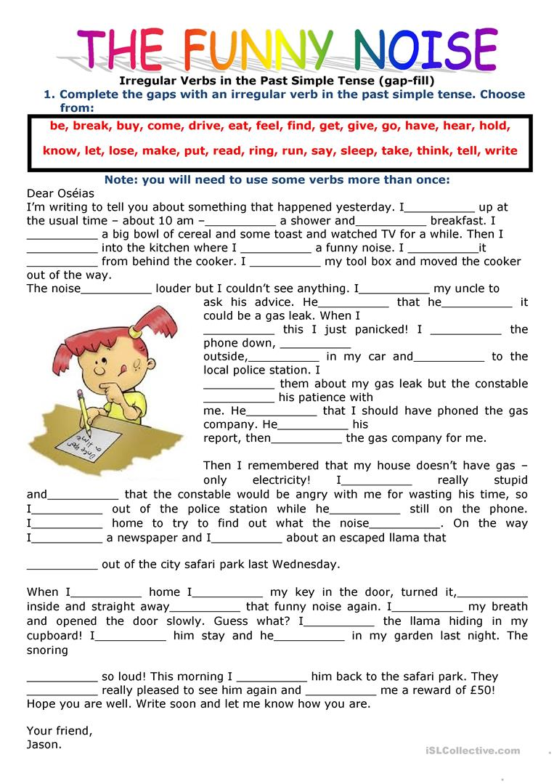

The past tense of To Be in English has two forms: WAS and WERE

To Be - Affirmative
Subject | To Be | Examples
I | was | I was tired this morning.
You | were | You were very good.
He | was | He was the best in his class.
She | was | She was late for work.
It | was | It was a sunny day.
We | were | We were at home.
You | were | You were on holiday.
They | were | They were happy with their test results.

To Be - Negative Sentences

The negative of To Be can be made by adding not after the verb (was or were).
Subject | To Be | Examples
I | was not | I was not tired this morning.
You | were not | You were not crazy.
He | was not | He was not married.
She | was not | She was not famous.
It | was not | It was not hot yesterday.
We | were not | We were not invited.
You | were not | You were not at the party.
They | were not | They were not friends.

To Be - Negative Contractions
We can make negative contractions of the verb To Be in the Past tense by joining the verb (was or were) and n't (e.g. were not = weren't). We don't make a contraction of the subject and the verb (e.g. I was).
I was not tired this morning. | OR | I wasn't tired this morning.
You were not crazy. | OR | You weren't crazy.
He was not married. | OR | He wasn't married.
She was not famous. | OR | She wasn't famous.
It was not hot yesterday. | OR | It wasn't hot yesterday.
We were not invited. | OR | We weren't invited.
You were not at the party. | OR | You weren't at the party.
They were not friends. | OR | They weren't friends.

To Be - Questions
To create questions with To Be, you put the Verb before the Subject.
Affirmative | You | were | happy.
 | Subject | Verb
Question | Were | you | happy?
 | Verb | Subject

Affirmative | Question
I was late | Was I late?
You were sick. | Were you sick?
He was surprised. | Was he surprised?
She was from Italy. | Was she from Italy?
It was a big house. | Was it a big house?
We were ready. | Were we ready?
You were early. | Were you early?
They were busy. | Were they busy?

Before the verb you can also have a WH- Question word (Why, Who, What, Where etc.)

Were you happy? Yes, I was.
Why were you happy? Because I was promoted at work.

8. Complete the sentences with the right past tense of BE

- The trip to Cartagena _________ fantastic
- At school, Simon and me, __________ bullied a lot.
- Last night I went to the cinema, but the film ________ boring
- Our school trip to the aquarium __________ awesome
- I didn’t like the arts workshop we took last weekend, because it ________ funny

